

**Student Assessment Submission and Declaration**

When submitting evidence for assessment, each student must sign a declaration confirming that the work is their own.

|  |  |  |  |
| --- | --- | --- | --- |
| Student name: Thet Phoo Wai | | Assessor name: Jeyashreee Rajkumar | |
| Issue date: 2/ 27/ 2023 | Submission date: 3/ 7/ 2023 | | Submitted on: 3/ 7/ 2023 |
| Programme: Pearson BTEC Level 5 HND in Application Development | | | |
| Unit: 13 Web Design and Development | | | |
| Assignment number and title: 1 of 2: Development of website for a Training Organization – Part 1 | | | |

**Student Declaration**

|  |
| --- |
| **Student declaration**  I certify that the assignment submission is entirely my own work and I fully understand the consequences of plagiarism. I understand that making a false declaration is a form of malpractice.  Student signature: Julia Date: **3/ 7/ 23** |



Pearson Education 2018

Higher Education Qualifications

Table of Contents

DNS: 3

How does DNS operate? 4

Purpose of DNS 4

Types of DNS 4

Types of DNS Records: 5

How Domain Names are Organized and Managed: 6

Communication Protocols 7

Server Hardware 8

Operating Systems 8

Web Server Software: 9

Software 10

Front-End Website Technologies 11

Back-End Website Technologies 11

Relationships Between Front-End and Back-End Technologies 12

How the Presentation and Application Layers Relate to Front-End and Back-End 13

Online Website Creation Tools 13

Custom-Built Sites 14

Online Websites and Custom-Built Websites 15

Introduction To the Project: 16

Purpose of DoBu Martial Arts 16

Client and User Requirements 16

System Requirements 17

Information Architecture 19

Wireframes 20

Testing the Website: 87

Web Design Principles: 105

Standards: 105

Guidelines: 105

Appropriate Test Plan 105

# DNS:

The Internet functions through a system known as the Domain Name System (DNS), which operates like an online phonebook[1]. People utilize domain names - such as nytimes.com or espn.com - to navigate and access content on the web whilst IP addresses allow for communication between computer systems. Essentially, DNS serves by converting user-friendly domain names into numerical sequences of characters utilized in internet-based communications – Google's easy-to-remember address "google.com" may be translated into its corresponding numeric counterpart "172.217.6.206."

When a user types a domain name into their web browser, the browser makes a request to a DNS server to translate the domain name into an IP address. The DNS server subsequently provides the browser with the IP address, enabling it to connect to the proper web server and load the requested webpage.

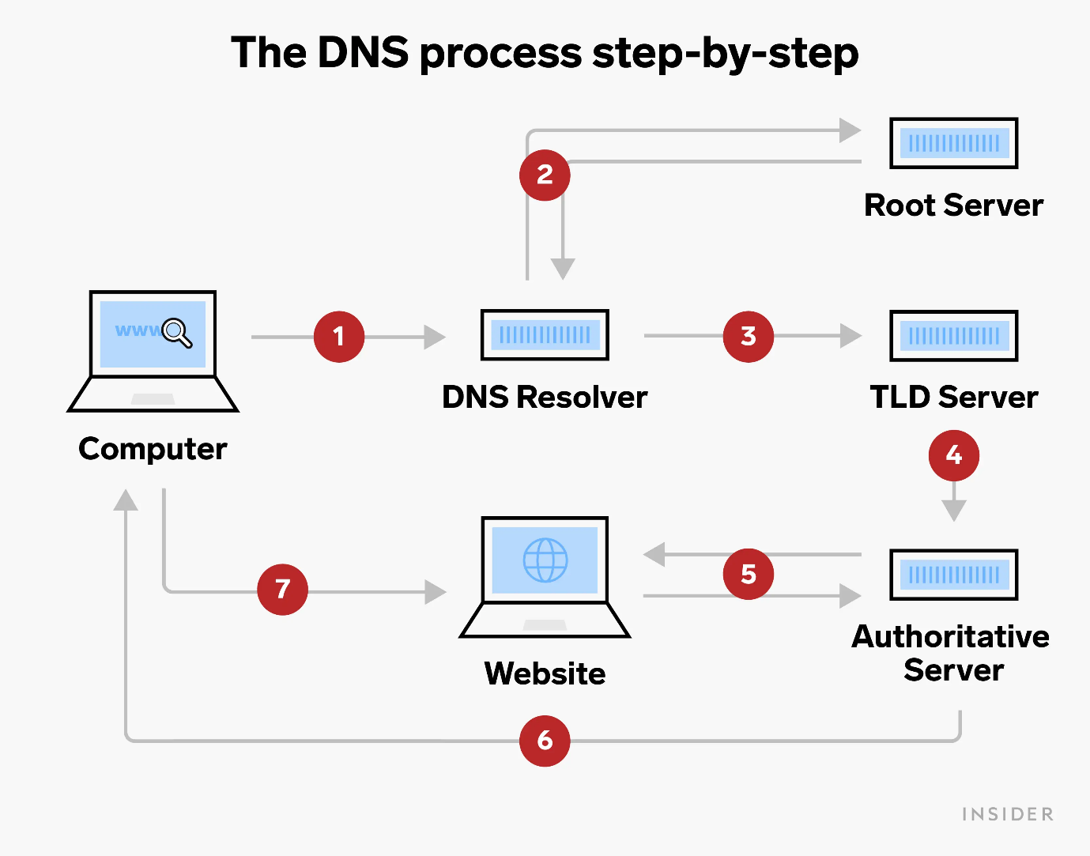

//(Source: laptrinhx.com)//

Since 1985, DNS has been a crucial part of the internet infrastructure that enables us to send and receive emails, view websites, and use a variety of online services.

# How does DNS operate?

The DNS system is in charge of converting domain names that can be read by humans into IP addresses that can be read by computers. DNS resolution includes translating a hostname (such as www.example.com) into an IP address that computers can understand (such as 192.168.1.1). Each Internet-connected device has an IP address, which is required to identify the correct Internet device, much as a street address is required to identify a certain residence [2].

The browser asks the DNS resolver to find the IP address associated with a domain name when a user inserts the URL of a website into their browser. The resolver subsequently gets in touch with the root DNS server, which points it in the direction of the proper Top-Level Domain (TLD) server. The TLD server then points the resolver toward the domain's authoritative DNS server, which stores the IP address linked to that domain name.

The user's browser can then connect to the server hosting the website by using the IP address that the resolver returns to it. Users can visit websites fast and simply without having to know the associated IP addresses thanks to this speedy operation, which takes place in a matter of moments.

# Purpose of DNS

The goal of DNS is to make it easier for people to locate and identify resources on the internet. Without DNS, it would be impracticable and cumbersome for users to remember and type in the IP addresses of the websites they want to visit. DNS makes it possible for users to obtain websites with simple-to-remember domain names while working behind the scenes to translate the domain name to an IP address and create a connection to the website's server.

Essentially, DNS's goal is to make it simpler for consumers to navigate and access online resources by substituting human-readable domain names for numerical IP addresses.

# Types of DNS

In the domain name system, there are various types of DNS, each with a distinct function. The most common varieties of DNS include:

Recursive DNS Servers:

Recursive DNS servers are in charge of answering requests by repeatedly requesting information from other DNS servers until the desired domain name is located. After the IP address is located, it is transmitted back to the user's computer so they may access the website or service they are seeking to connect to. Internet service providers (ISPs) usually employ this kind of DNS server to cache frequently requested domain names, hence speeding up domain name resolution.

Authoritative DNS Servers:

Keeping and updating DNS records for a certain domain name is the responsibility of authoritative DNS servers. An authoritative DNS server receives the IP address linked to the domain name when a recursive DNS server queries it. Every domain name has a unique authoritative DNS server that is in charge of keeping track of all of its DNS records, including IP addresses and other pertinent data. To administer their domain names and related IP addresses, website owners and domain name registrars utilize this sort of DNS server.

TLD DNS Servers:

You might see the top-level domain server (TLD) as a particular shelf of books in a library. The final part of a hostname is hosted by this nameserver, which is the following stage in the process of locating an IP address (in the case of example.com, the TLD server is "com") [3]. These DNS servers are run by companies who have been given control over a certain TLD.

Root DNS Servers:

The root servers are the first place where human readable host names are converted (resolved) into IP addresses. In the domain name system hierarchy, root DNS servers are the highest-level DNS servers. These servers are in charge of directing requests to the proper TLD DNS servers and maintaining the authoritative DNS records for all top-level domains.

# Types of DNS Records:

* A domain name's DNS (Domain Name System) records are used to store several kinds of information about it. There are various sorts of DNS records, each with a distinct function.
* A (Address) Record: A domain name and IP address are mapped using this sort of record. As an illustration, the A record will inform a user's browser that the IP address associated with the domain name "www.example.com" is, for instance, "192.168.1.1."
* NS (Name Server) Record: This sort of record identifies the name servers in charge of a specific domain. It is used throughout the resolution process to specify which DNS server is the authoritative one for a domain.
* MX (Mail Exchanger) Record: This kind of record is employed to specify the email server or servers in charge of receiving email delivered to a domain. Which server is in charge of handling incoming emails is specified.
* TXT (Text) Record: In DNS, this kind of record is used to store any kind of text data. SPF (Sender Policy Framework) records for email authentication, domain ownership verification, and other uses are all possible with it.
* CNAME (Canonical Name) Record: A domain name may serve as an alias for another domain name thanks to a CNAME record. For instance, you may use a CNAME record to make sure that two different domain names pointing to the same website resolve to the same IP address.
* AAAA (IPv6 address) Record: An AAAA record links a domain name to an IPv6 address, much like an A record does. To connect to websites or servers that support IPv6, use this method.
* SRV (Service) Record: The placement of servers for particular services within a domain is specified by this record. VoIP (Voice over IP) or instant messaging services frequently use this.

Knowing these various DNS record kinds can assist website owners maintain their domain names and make sure that their online services run without a hitch.

# How Domain Names are Organized and Managed:

We refer to the concise terms used for websites on the web as domain names. The DNS system, which is decentralized and hierarchical in its approach towards computer-based resources connected through internet service or a private network, oversees and facilitates management of these unique identifiers. Based on the domain hierarchy, the DNS categorizes domain names into distinct levels, such as top-level domains (TLDs), second-level domains, and subdomains.

The TLDs, which are the top-level domain names in the DNS, are at the top of the hierarchy. The regulatory responsibility over these TLDs belongs to the Internet Assigned Numbers Authority (IANA). These top-level domains comprise generic TLDs, such as com, org, and net; and country-code TLDs including us, ca and uk. Subdomains are produced by appending a prefix to a second-level domain, which is underneath the TLDs.

Second-level domains are located under each TLD and are maintained by domain registrars on behalf of private persons, companies, and other organizations. These domain registrars serve as go-betweens for the registrants and the TLD registry administrators, handling the registration procedure and making sure the domain name is available.

Corporations authorized by ICANN to market domain names to the public are deemed as Domain name registrars. These companies handle and arrange domain titles seamlessly across networks online. A user who wishes to register a domain name must utilize a registrar and submit their contact and payment details. The relevant registry receives the domain name information from the registrar and is in charge of managing the DNS records for the TLD or second-level domain.

Generally, the DNS system and its administration ensure that domain names are arranged and accessible on the internet, simplifying user navigation and resource discovery.

# Communication Protocols

The DoBu Martial Arts website is a complicated system with interdependent hardware and software elements. Fundamentally, the website is made with the aid of specialist applications like HTML, CSS, JavaScript, and PHP, which are used to develop the website's organizational structure, visual aesthetic, and interactive elements. Computers, servers, and routers are some of the hardware components required to build and publish the website. These gadgets are in charge of keeping the website files safe and making sure that everyone who wants to access the website may do so.

Communication protocols are employed while viewing the DoBu Martial Arts website to make it easier for data to be transferred between the website and the user's device. For routine website queries, the HTTP protocol is used, whereas HTTPS is used for secure communication. The SMTP protocol is used for sending and receiving email, whereas the FTP protocol is used for file transfers.

To guarantee trustworthy data transmission between these servers and clients, communication protocols like TCP/IP (Transmission Control Protocol/Internet Protocol) are utilized.

The DNS protocol is also crucial for accessing the DoBu Martial Arts website. The user's device can access the website's files and content because it converts the domain name of the website into an IP address that it can recognize.

Ultimately, the interactions between the hardware and software needed to create, publish, and access the DoBu Martial Arts website are intricate yet necessary for delivering a smooth and engaging user experience. The website can be viewed from almost anywhere in the globe thanks to cutting-edge software, strong hardware, and dependable connection protocols. It gives users the knowledge and resources they need to interact with the DoBu Martial Arts community.

# Server Hardware

There are a number of hardware specifications that must be met in order to develop and publish a website like DoBu Martial Arts. They consist of a potent processor, enough RAM, and lots of storage. Depending on the intricacy of the website and the volume of traffic it receives, the precise hardware requirements may change.

|  |  |
| --- | --- |
| Hardware Component | Minimum Requirements |
| Operating System | Windows 10 or macOS High Sierra or later |
| Processor | Intel Core i5 or equivalent |
| RAM | 8 GB |
| Storage | 256 GB SSD |
| Graphics Card | NVIDIA GeForce GTX 1050 or equivalent |
| Display | 1920 x 1080 resolution |

# Operating Systems

The relationship between hardware and software needed to create, publish, and access the DoBu Martial Arts website depends on the operating system. Memory, storage space, and input/output devices are just a few of the resources that the operating system is in charge of controlling. It offers a platform on which software programs can execute and communicate with hardware.

The performance and security of the website might be significantly impacted by the operating system selection. Windows, macOS, and Linux are a few of the common operating systems used for web development. While macOS is renowned for its dependability and compatibility with other Apple products, Windows is frequently chosen for its simplicity of use and compatibility with well-known software programs. Due to its dependability, security, and open-source nature, Linux is a preferred option for web servers.

The DoBu Martial Arts website's operating system will be chosen based on the preferences and experience of the creators. But in order to reduce the danger of security vulnerabilities, it's crucial to make sure the operating system is current with the most recent security patches and upgrades.

To sum up, the operating system plays a crucial role in the interaction between hardware and software that creates, publishes, and allows users to access the DoBu Martial Arts website. It offers a platform on which software programs can run, interact with hardware, and affect the speed and security of the website.

# Web Server Software:

* Web Server Software to Access and Publish DoBu

A web server program is required to host and serve web pages in order to build, publish, and access the DoBu Martial Arts website. The web server software serves the user's browser with the requested web pages by acting as a middleman between the website content and browser.

Apache Tomcat is a widely used open-source web server that offers a framework for hosting and running Java-based web applications. An additional well-liked web server program is Xampp, a cross-platform web server that supports Apache, MySQL, PHP, and Perl and enables users to host dynamic websites that employ these technologies.

The web server software must be accessed via particular protocols in order for users to view and post material on the DoBu Martial Arts website. For instance, HTTP and HTTPS are popular protocols for navigating websites online. While emails are sent and received using SMTP, files are transferred between computers using FTP.

In brief, the hardware and software that are used to create, publish, and access the DoBu Martial Arts website are connected and depend on one another to function properly. In order to access and publish content on the website, special communication protocols are necessary, and the web server software serves as the intermediary between the website content and the user's browser.

* Apache Tomcat Server

The DoBu Martial Arts website is hosted by the Apache Tomcat web server software, which is frequently used to host Java-based online applications. Tomcat is an open-source server that works with a variety of operating systems, including Windows, Linux, and macOS.

The Tomcat server functions as an HTTP server, which means that it watches for incoming requests from web browsers and answers those requests by delivering the relevant web page or resource. Tomcat employs the HTTP protocol and by default listens on port 80 for requests. It can be set up to listen on several ports, including port 443 for HTTPS queries, though.

The website's code must be packaged as a web application and deployed on the Tomcat server in order to publish the DoBu Martial Arts website using Tomcat. Tools like Eclipse or Apache Maven can be used for this. The relevant URL, which contains the server's IP address or domain name and the web application's context path, can be entered in a web browser to visit a web application after it has been deployed.

In conclusion, Apache Tomcat is a crucial part of the architecture of the DoBu Martial Arts website, providing the framework for hosting and delivering the website's content to end users via HTTP requests. It enables the website to produce dynamic content and communicate with visitors via forms, authentication systems, and other essential features for a contemporary web application.

# Software

|  |  |  |
| --- | --- | --- |
| **Software** | **Purpose** | **Description** |
| Balsamiq | To build Information Architecture (IA) and Storyboard | A quick wireframing tool for making preliminary layout of websites |
| Mockplus | To create mockups and wireframes for the website's design | A prototyping tool that enables designers to make interactive mockups of the pages and features of a website |
| Apache Tomcat | Act as the web server for the website's hosting | The DoBu website is hosted on an open-source web server, which gives users access |
| MS Word | To compose and edit articles for blogs and other websites | A word processing program that may be used to draft and update text-based internet content, like blog posts and articles |
| MS PowerPoint | To make presentations for the website by designing them | A presentation tool that may be used to provide multimedia material and visual assistance for the website |
| VS Code | For creating and modifying HTML, CSS, and JavaScript files, use a code editor | The HTML, CSS, and JavaScript code for the website is written and edited by developers using text editors. To make coding easier, they include tools like syntax highlighting and code completion |
| Web browsers | Used to view and access the website across many platforms | Users access the DoBu website and its information via browsers |

# Front-End Website Technologies

The DoBu Martial Arts website's user interface and presentation layer are both created using front-end website technology. This comprises the user-interface design, layout, and functionality. DoBu uses the front-end technologies HTML, CSS, and JavaScript.

Making a responsive and engaging user interface is one of the main functions of front-end website technologies. The usage of several programming languages, including HTML, CSS, and JavaScript, can be used to do this. For instance, a website's content is structured and organized using HTML, the visual presentation is styled using CSS, and interactive features like animations, pop-up windows, and drop-down menus are added using JavaScript.

The ability of front-end website technology to enhance user experience and increase website performance is another crucial feature. Tools and methods including browser caching, compression, and image optimization can be used to achieve this. For instance, using compressed pictures can drastically shorten a webpage's load time, which can enhance the user experience overall.

The link between front-end and back-end website technologies is frequently very tight. An entire web application can be built using a combination of front-end tools like React or Vue.js and back-end tools like Node.js or Django. In order to display dynamic content on a website, front-end technologies also frequently rely on the data supplied by back-end technologies.

A successful website like DoBu depends on the abilities and connections of front-end and back-end website technology. Together, these technologies enable a user experience that is dynamic, captivating, and both utilitarian and aesthetically pleasing.

# Back-End Website Technologies

Back-end website technologies are in charge of managing data, security, and interfaces with databases as well as the server-side logic of a website. The front-end layer receives user requests from the back-end layer, processes them, and sends the relevant responses back to the front-end layer.

The following are a few examples of back-end technology used by the DoBu website:

* PHP: PHP is a commonly used server-side scripting language for creating websites. Due to its simplicity of use and compatibility for a variety of databases, it is a well-liked option for creating back-end applications.
* Node.js: A JavaScript runtime environment with cross-platform compatibility is Node.js. Scalable network applications, such as back-end web applications, are frequently built using it.
* Apache: A well-known open-source web server program is Apache. It may be set up to support a number of programming languages and databases and is frequently used to host web applications.

In general, back-end website technologies are necessary for the DoBu website to operate well. They collaborate with front-end technology to deliver a smooth user experience and make sure the website is responsive, dependable, and safe.

# Relationships Between Front-End and Back-End Technologies

The DoBu Martial Arts website's front-end and back-end technology collaborate to offer a smooth user experience. Whereas the front-end technologies control the user interface and user experience, such as page layouts, interactive features, and multimedia content, the back-end technologies handle server-side processing, such as database management, data processing, and server-side scripting.

For instance, the back-end technology must be able to comprehend and handle requests made by JavaScript if the front-end uses it to communicate with the back end. The back-end technology may also need to be updated in order to accommodate changes to the front-end technology, such as redesigning the website's design or user interface.

The DoBu Martial Arts website's front-end and back-end technology relationships, which both work together to provide the necessary functionality and engagement for the website's users, are crucial to creating a seamless and effective user experience.

The Capabilities of Front-End Technologies for the DoBu Website Include:

* Designing a user-friendly and aesthetically pleasing website interface.
* Creating and implementing HTML, CSS, and JavaScript-based website layouts.
* Adding multimedia components to the website, such as photographs, movies, and audio.
* To ensure compatibility with a range of devices and screen sizes, develop responsive design.
* Delivering dynamic features including user input validation, animations, and real-time updates.

The Capabilities of Back-End Technologies for the DoBu Website Include:

* Database archiving and data retrieval for website functioning.
* Developing server-side applications using programming languages like PHP, Python, or Ruby.
* Putting authentication and permission procedures in place to protect the website.
* Implementing APIs to enable connectivity between various web services and applications.
* Enhancing server resource management and response time to enhance website performance.

# How the Presentation and Application Layers Relate to Front-End and Back-End

On the DoBu website, front-end and back-end technology collaborate to provide a smooth user experience. The presentation layer, which is the area of a website that visitors directly interact with, is handled by front-end technology. It is in charge of the design, appearance, and functionality of the website. The application layer, which is in charge of the website's functionality, is handled by the back-end technology.

To retrieve data and carry out tasks, front-end technologies communicate with back-end technologies. The back end receives requests from the front-end and processes them, returning the required data. The information is subsequently displayed to the user by the front-end using this data. For instance, when a user clicks a button to access their account information, the front-end sends a request to the back end, which then retrieves the user's information and delivers it back to the front-end. The user is then presented with the information by the front-end in an aesthetically pleasant and intuitive way.

In conclusion, the integration of front-end and back-end technology results in a seamless user experience. The application layer is handled by the back end, while the presentation layer is handled by the front-end. To retrieve and provide data to the user, they exchange messages with one another.

# Online Website Creation Tools

Online website creation tools, commonly known as Content Management Systems (CMS), are web applications that allow users to create, manage and publish digital material without requiring sophisticated technical expertise. These tools frequently come with drag-and-drop interfaces, templates, and pre-built modules and plugins that make it simple to add features like forms, galleries, and eCommerce functionality to websites.

Examples of online CMSs or tools for building websites include:

* WordPress: With more than 40% of all websites on the internet utilizing it, WordPress is one of the most widely used CMS platforms in use today. Strong SEO capabilities are offered, along with a wide library of themes and plugins that are very configurable.
* Drupal: Drupal is a more sophisticated CMS than WordPress, with a steeper learning curve but more flexibility and security. Large-scale websites with intricate content management requirements frequently use it.
* Wix: It is a cloud-based website builder with a drag-and-drop user interface that allows for the creation and customization of webpages. Users can choose from a huge selection of templates and apps thanks to it.
* Shopify: It is an e-commerce platform that offers resources for setting up an online store and conducting online sales. To further modify the look and operation of the website, it also provides a variety of themes and plugins.
* Squarespace: Website builders like Squarespace are well-known for their slick, contemporary themes. It offers a variety of customization possibilities and integrations with well-liked third-party e-commerce, blogging, and other apps.
* Joomla: A free and open-source CMS with cutting-edge features including user administration, multi-language support, and customized modules.

For those who lack technical expertise or experience, using an online website design tool or CMS can make the process simpler and faster. When compared to custom-built sites, they could have less design flexibility, performance, and usefulness.

# Custom-Built Sites

Websites that are designed from the ground up using programming languages like HTML, CSS, JavaScript, and others are referred to as custom-built sites. Custom-built websites, in contrast to online website creation tools, are created by qualified web developers or development teams and are created particularly to meet the needs and specifications of the website's owner.

Sites that are designed specifically for a business can be entirely customized in terms of functionality and design, providing a great level of flexibility. This degree of personalization enables distinctive branding and more individualized user experiences for site visitors.

Some samples of a custom-built website are:

* Amazon – one of the biggest e-commerce websites in the world, Amazon was created from the ground up and has a highly tailored user experience to meet the specific requirements of its users.
* Spotify – a worldwide streaming music service with millions of users. Personalized user recommendations, real-time updates, and sophisticated audio and video streaming functionalities are all supported by the website.
* Apple – the Apple website is an illustration of a highly personalized website that is created to present the company’s goods and services aesthetically and intuitively. The website has a slick, minimalist design, interactive elements, and original animations.

# Online Websites and Custom-Built Websites

Both custom-built websites and online websites building tools offer advantages and disadvantages in terms of design flexibility, functionality, performance, user experience (UX), and user interface (UI).

|  |  |  |
| --- | --- | --- |
| Aspects | Online Website Creation Tools | Custom-Built Sites |
| Design Flexibility | Due to the usage of pre-made templates and themes, there is little design freedom and modification potential | Due to the possibility to develop a bespoke design suited to the particular requirements of the website, there are more options for customization and design flexibility |
| Performance | The constraints and restrictions of the platform used to create the website may have an impact on performance | More optimization control over website speed enables quicker load times and better overall performance |
| Functionality | Due to the use of pre-built plugins and modules, there are fewer functional options available | The ability to develop bespoke features and integrations results in more functional alternatives |
| User Experience (UX) | Minimal control over the overall user experience due to the website's pre-built components and template-driven layout | More control over the user experience enables more individualized and user-friendly website design |
| User Interface (UI) | Minimal control over the user interface since pre-built elements and templates determine the website's design and layout | More user interface control enables more distinctive and aesthetically pleasing designs |

# Introduction To the Project:

The goal of the DoBu Martial Arts website project is to establish an online platform for martial arts schools to communicate with their current and potential consumers. The website will act as a one-stop shop for all data pertaining to the studio, such as classes, instructors, timetables, events, and costs.

The objective is to develop a website that is easy to use, visually appealing, and informative and that truly expresses the studio's culture, values, and dedication to martial arts training excellence. Also, the website will offer a simple method for users to schedule appointments, register for classes, and make payments online.

# Purpose of DoBu Martial Arts

The DoBu Martial Arts website serves as a digital platform for the martial arts school to advertise its offerings, inform potential customers, and let current customers manage their accounts. The website should have a simple, contemporary style that conveys the studio's professionalism. It should also be available from a variety of platforms, such as PCs, laptops, tablets, and mobile phones, and have a user-friendly interface.

# Client and User Requirements

The following user acceptability standards and functional and non-functional needs were identified for the creation of the DoBu Martial Arts website:

Functional Requirements:

* The homepage of the website ought to include a summary of the services that DoBu Martial Arts offers.
* The website ought to contain a page listing the upcoming classes and letting visitors sign up for them.
* A  section on the website should have updates on the most recent activities at DoBu Martial Arts as well as relevant information about martial arts.
* A gallery area on the website should feature pictures and videos of the facilities and activities of DoBu Martial Arts.
* The studio personnel should be able to easily view and edit the website's class schedule.
* Users should be able to sign up for classes and create accounts on the website.
* Users should be able to submit queries or requests for more information via a contact form on the website.

Non-Functional Requirements:

* The website must have a responsive layout that is suitable for both desktop and mobile usage.
* The website should have simple menus and page layouts that are easy to understand and use.
* The website needs to load quickly and be search engine optimized.
* Strong security measures should be in place on the website to safeguard user data and thwart hacker attempts.
* The website should work with widely used operating systems and web browsers.

User Acceptance Criteria:

* The website should have a pleasing aesthetic and convey the DoBu Martial Arts brand.
* The website should have simple menus and page layouts that are easy to understand and use.
* Both desktop and mobile users should have no trouble accessing the website, which should load rapidly.
* The website must offer precise and current information about the projects and services offered by DoBu Martial Arts, as well as contact details.
* The website must be safe and secure in order to guard against theft or unauthorized access to user data.

# System Requirements

System requirements are the specifications for the hardware and software needed to correctly execute the website. The system requirements for the DoBu Martial Arts website can be divided into two groups: software requirements and hardware requirements.

Hardware Requirements:

Users will require a computer or mobile device that satisfies the following minimal hardware specifications in order to use the DoBu Martial Arts website:

* An internet-connected PC or mobile device
* A web browser like Safari, Mozilla Firefox, or Google Chrome
* A screen with a minimum resolution of 1024 by 768 pixels
* A seamless online browsing experience is ensured by sufficient RAM and processing power
* A modern operating system, like MacOS 11.0 or Windows 10

Software Requirements:

The DoBu Martial Arts website requires the following software to function:

* A content management system (CMS) that supports the CMS of choice, such as WordPress
* Plugins and add-ons required for the functionality and features of websites
* A safe browsing SSL certificate
* Compatibility with many devices and web browsers

These are the fundamental computer hardware and operating system requirements for the DoBu Martial Arts website. It's vital to remember that these specifications could alter based on the website's complexity, user volume, and other elements.

# Information Architecture

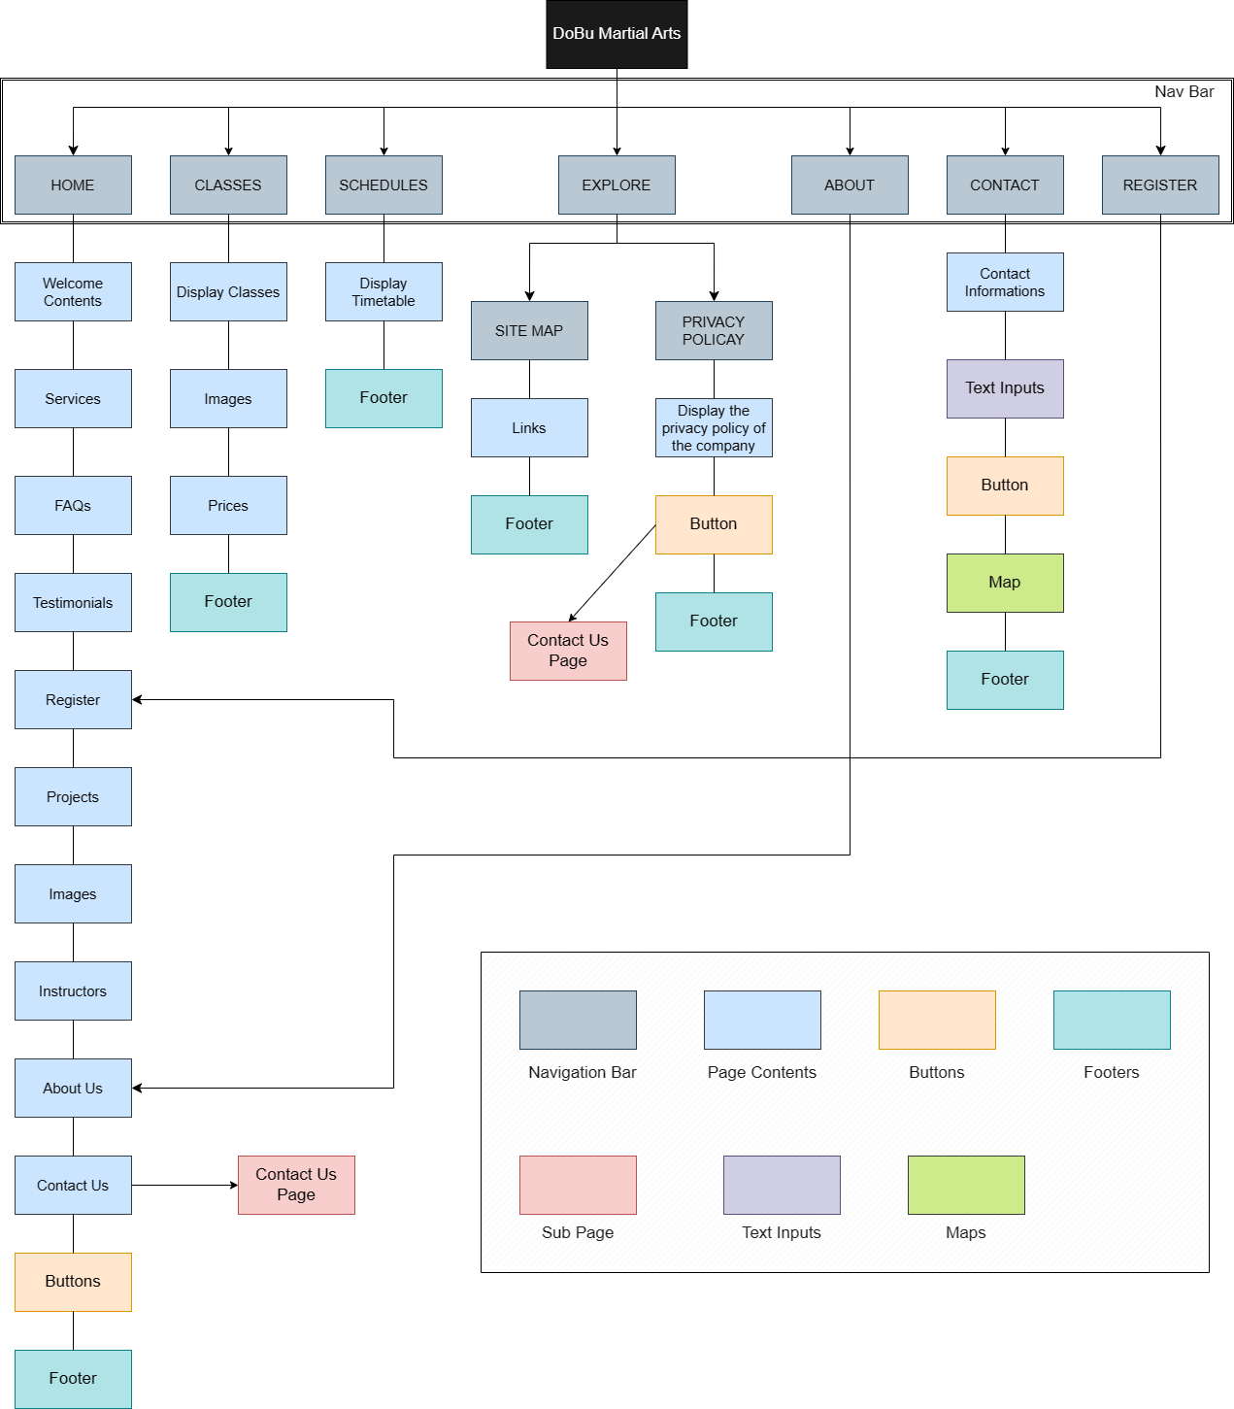

# Wireframes

*Home Page*

A slideshow, featured courses, and a call-to-action are just a few examples of the main content and pieces that could be displayed in the home page wireframe.

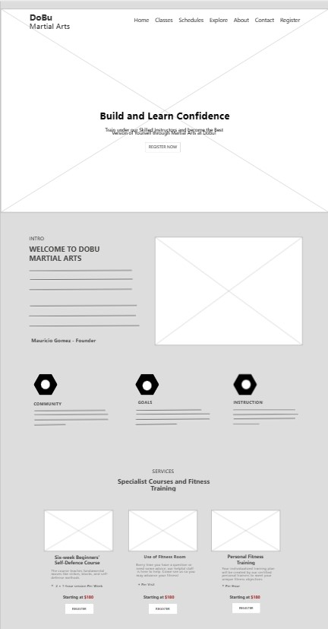

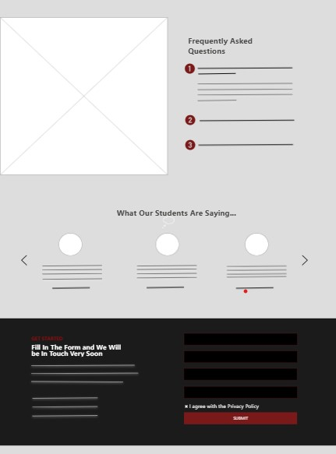

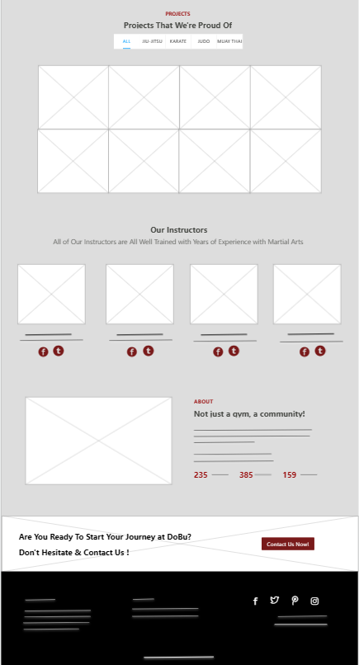

*Classes Page*

The structure and positioning of important features, like the classes name, description, and any other pertinent information, could be shown in the wireframe for the classes page.

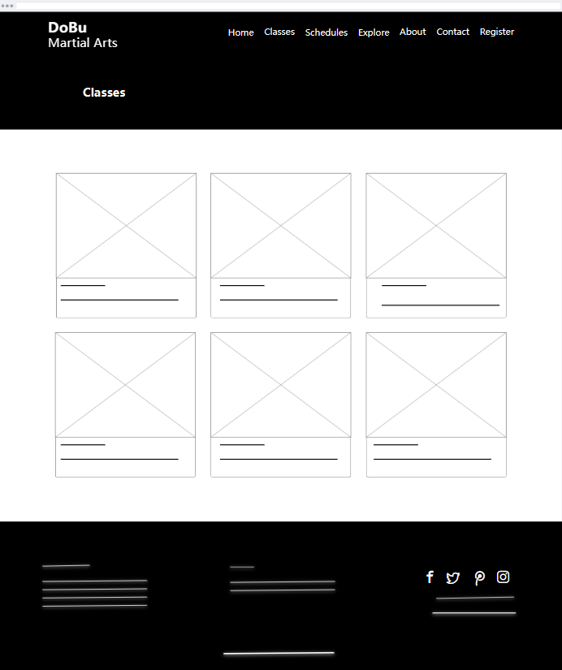

*Schedules Page*

The course schedule page wireframe could display the design and positioning of the course schedule, the beginning and ending dates of each course, and any other pertinent details.

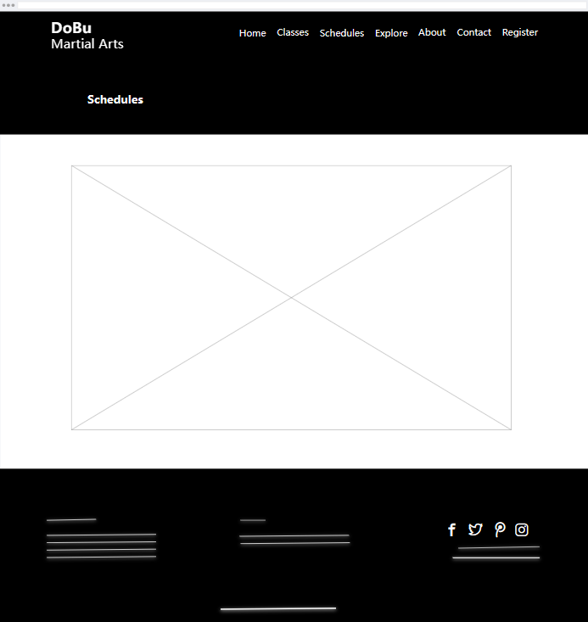

*Contact Page*

The structure and positioning of the contact form, the firm address, as well as any other pertinent information that must be included on this page, might all be shown in the wireframe for the contact us page.

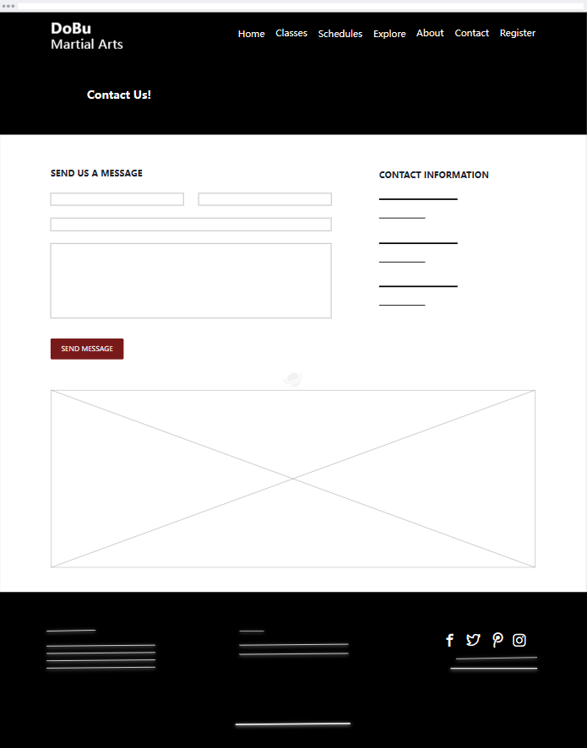

*Privacy Policy Page*

The style and positioning of the company's privacy policy, as well as any pertinent information like data collecting and usage policies, may be shown in the privacy policy page wireframe.

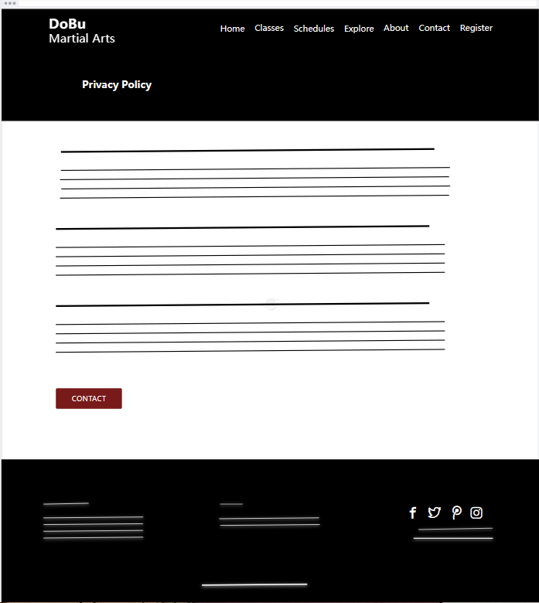

*Site Map Page*

A website's site map is a page that displays a hierarchical diagram of all the site's pages and sections. Users can simply navigate to the pages they want to visit thanks to the overview it provides of the website's content and structure. Links to the website's most crucial pages, such as the home page, about us page, contact us page, and other sections or pages, are generally included in site maps.

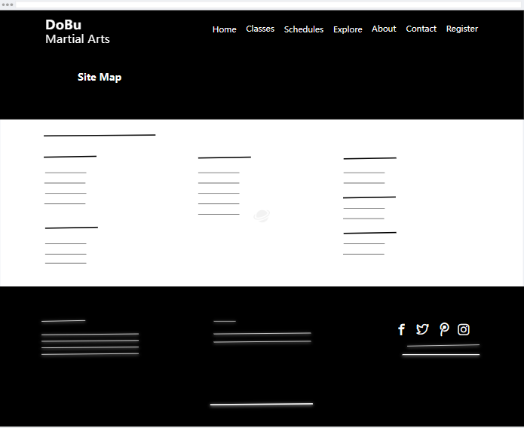

Index.html

|  |
| --- |
| <!DOCTYPE html>  <html lang="en">      <head>          <meta charset="utf-8">          <meta name="viewport" content="width=device-width, initial-scale=1, shrink-to-fit=no">            <!-- Title -->          <title>Dobu</title>            <!-- Styles -->          <link href="https://fonts.googleapis.com/css2?family=Montserrat:wght@700&family=Open+Sans:ital,wght@0,400;0,700;1,400&display=swap" rel="stylesheet">          <link href="css/bootstrap.min.css" rel="stylesheet">          <link href="css/fontawesome-all.min.css" rel="stylesheet">          <link href="css/swiper.css" rel="stylesheet">          <link href="css/styles.css" rel="stylesheet">          <script src="https://kit.fontawesome.com/f57991b77d.js" crossorigin="anonymous"></script>              <!-- Favicon  -->          <link rel="icon" href="images/favicon.png">      </head>      <body data-bs-spy="scroll" data-bs-target="#navbarExample">            <!-- Navigation -->          <nav id="navbarExample" class="navbar navbar-expand-lg fixed-top navbar-dark" aria-label="Main navigation">              <div class="container">                  <!-- Logo -->                  <a href="index.html" class="navbar-brand-logo"> D̶o̶B̶u̶  <p>MARTIAL ARTS</p></a>                  <button class="navbar-toggler p-0 border-0" type="button" id="navbarSideCollapse" aria-label="Toggle navigation">                      <span class="navbar-toggler-icon"></span>                  </button>                  <div class="navbar-collapse offcanvas-collapse" id="navbarsExampleDefault">                      <ul class="navbar-nav ms-auto navbar-nav-scroll">                          <li class="nav-item">                              <a class="nav-link" href="#header">Home</a>                          </li>                          <li class="nav-item">                              <a class="nav-link" href="classes.html">Classes</a>                          </li>                          <li class="nav-item">                              <a class="nav-link" href="schedules.html">Schedules</a>                          </li>                          <li class="nav-item dropdown">                              <a class="nav-link dropdown-toggle" href="#" id="dropdown01" data-bs-toggle="dropdown" aria-expanded="false">Explore</a>                              <ul class="dropdown-menu" aria-labelledby="dropdown01">                                  <li><a class="dropdown-item" href="sitemap.html">Site Maps</a></li>                                  <li><div class="dropdown-divider"></div></li>                                  <li><a class="dropdown-item" href="privacy.html">Privacy Policy</a></li>                              </ul>                          </li>                          <li class="nav-item">                              <a class="nav-link" href="#about">About</a>                          </li>                          <li class="nav-item">                              <a class="nav-link" href="contact.html">Contact</a>                          </li>                          <li class="nav-item">                              <a class="nav-link" href="#registration">Register</a>                          </li>                      </ul>                    </div>              </div>          </nav>          <!-- end of navigation -->            <!-- Header -->          <header id="header" class="header">              <div class="container">                  <div class="row">                      <div class="col-lg-12">                          <div class="text-container">                              <h1 class="h1-large">Build and Learn <span class="replace-me">Confidence, Self-Defense, Fitness</span></h1>                              <p class="p-large">Train under our Skilled Instructors and become the Best Version of Yourself through Martial Arts at Dobu!</p>                              <a class="btn-solid-lg" href="#registration">REGISTER NOW</a>                          </div>                      </div>                  </div>              </div>          </header>          <!-- end of header -->          <!-- Intro -->          <div id="intro" class="basic-1">              <div class="container">                  <div class="row">                      <div class="col-lg-5">                          <div class="text-container">                              <div class="section-title">INTRO</div>                              <h2>WELCOME TO DOBU MARTIAL ARTS</h2>                              <p>In our gym, we firmly believe that training is the start of personal                                  mastery, self-discovery, and a brand-new you cause many of us have, in fact, experienced that</p>                              <p class="testimonial-text">"Martial arts are not exclusively about fighting, despite popular belief, we teach you self-defense skills.                                  Martial arts have been used for thousands of years as a vehicle for personal growth, self-awareness, and mastery"</p>                              <div class="testimonial-author">Mauricio Gomez - Founder</div>                          </div>                      </div>                      <div class="col-lg-7">                          <div class="image-container">                              <img class="img-fluid" src="images/thao-lee-Xl-ilWBKJNk-unsplash.jpg" alt="alternative">                          </div>                      </div>                  </div>              </div>          </div>          <!-- end of Intro -->          <!-- Description -->          <div class="cards-1">              <div class="container">                  <div class="row">                      <div class="col-lg-12">                            <!-- Card -->                          <div class="card">                              <span class="fa-stack">                                  <span class="hexagon"></span>                                  <i class="fas fa-users fa-stack-1x"></i>                              </span>                              <div class="card-body">                                  <h5 class="card-title">COMMUNITY</h5>                                  <p>Your time with us is so wonderful cause of our distinctive community. Join a group of upbeat,                                      entertaining, and kind people who are all striving for the same objective.</p>                              </div>                          </div>                          <!-- end of card -->                          <!-- Card -->                          <div class="card">                              <span class="fa-stack">                                  <span class="hexagon"></span>                                  <i class="fas fa-check fa-stack-1x"></i>                              </span>                              <div class="card-body">                                  <h5 class="card-title">GOALS</h5>                                  <p>Our priorities are your objectives. We design our programs to                                      support you in achieving those. We can assist you with confidence and focus as well as fitness and weight loss.</p>                              </div>                          </div>                          <!-- end of card -->                          <!-- Card -->                          <div class="card">                              <span class="fa-stack">                                  <span class="hexagon"></span>                                  <i class="fas fa-thumbs-up fa-stack-1x"></i>                              </span>                              <div class="card-body">                                  <h5 class="card-title">INSTRUCTION</h5>                                  <p>You can reach our qualified instructors right now! Our instructors' top concern is making                                      sure every class is special, enjoyable, and secure.</p>                              </div>                          </div>                          <!-- end of card -->                      </div>                  </div>              </div>          </div>          <!-- end of description -->          <!-- Services -->          <div id="services" class="cards-2 bg-gray">              <div class="container">                  <div class="row">                      <div class="col-lg-12">                          <div class="section-title">SERVICES</div>                          <h2 class="h2-heading">Specialist Courses and Fitness Training</h2>                      </div>                  </div>                  <div class="row">                      <div class="col-lg-12">                            <!-- Card -->                          <div class="card">                              <div class="card-image">                                  <img class="img-fluid" src="images/pexels-pavel-danilyuk-6295767.jpg" alt="alternative">                              </div>                              <div class="card-body">                                  <h4 class="card-title">Six-week Beginners’ Self-Defence Course</h4>                                  <p>The course teaches fundamental moves like strikes, blocks,                                      and self-defense methods</p>                                  <ul class="list-unstyled li-space-lg">                                        <li class="d-flex">                                          <i class="fas fa-square"></i>                                          <div class="flex-grow-1">2 × 1-hour session Per Week</div>                                      </li>                                  </ul>                                  <div class="price">Starting at <span>$180</span></div>                              </div>                              <div class="button-wrapper">                                  <a class="btn-solid-reg" href="#registration">REGISTER</a>                              </div>                          </div>                          <!-- end of card -->                          <!-- Card -->                          <div class="card">                              <div class="card-image">                                  <img class="img-fluid" src="images/pexels-mikhail-nilov-6739958.jpg" alt="alternative">                              </div>                              <div class="card-body">                                  <h4 class="card-title">Use of Fitness Room </h4>                                  <p>Every time you have a question or need some advice, our helpful staff is here to help.                                      Come see us so you may advance your fitness!</p>                                  <ul class="list-unstyled li-space-lg">                                        <li class="d-flex">                                          <i class="fas fa-square"></i>                                          <div class="flex-grow-1">Per Visit</div>                                      </li>                                  </ul>                                  <div class="price">Starting at <span>$6</span></div>                              </div>                              <div class="button-wrapper">                                  <a class="btn-solid-reg" href="#registration">REGISTER</a>                              </div>                          </div>                          <!-- end of card -->                          <!-- Card -->                          <div class="card">                              <div class="card-image">                                  <img class="img-fluid" src="images/pexels-annushka-ahuja-7991620.jpg" alt="alternative">                              </div>                              <div class="card-body">                                  <h4 class="card-title">Personal Fitness Training </h4>                                  <p>Your individualized training plan will be created by our certified                                      personal trainers to meet your unique fitness objectives</p>                                  <ul class="list-unstyled li-space-lg">                                        <li class="d-flex">                                          <i class="fas fa-square"></i>                                          <div class="flex-grow-1">Per Hour</div>                                      </li>                                  </ul>                                  <div class="price">Starting at <span>$35</span></div>                              </div>                              <div class="button-wrapper">                                  <a class="btn-solid-reg" href="#registration">REGISTER</a>                              </div>                          </div>                          <!-- end of card -->                      </div>                  </div>              </div>          </div>          <!-- end of Services -->          <!-- Details 1 -->          <div id="faq" class="accordion-1">              <div class="area-1">              </div><div class="area-2">                    <!-- Accordion -->                  <div class="accordion" id="accordionExample">                      <h2>Frequently Asked Questions</h2>                        <!-- Accordion Item -->                      <div class="accordion-item">                          <div class="accordion-icon">1</div>                          <div class="accordion-header" id="headingOne">                              <button class="accordion-button" type="button" data-bs-toggle="collapse" data-bs-target="#collapseOne" aria-expanded="true" aria-controls="collapseOne">                                  Do I Need Any Prior Experience to Enroll in a Martial Arts Class?                              </button>                          </div> <!-- end of accordion-header -->                          <div id="collapseOne" class="accordion-collapse collapse show" aria-labelledby="headingOne" data-bs-parent="#accordionExample">                              <div class="accordion-body">No, all skill levels, including beginners, are welcome in our classes.                                  Our instructors will work with you to make sure you are at ease and assured using the movements and techniques.</div>                          </div> <!-- end of accordion-collapse -->                      </div> <!-- end of accordion-item -->                      <!-- end of accordion-item -->                      <!-- Accordion Item -->                      <div class="accordion-item">                          <div class="accordion-icon blue">2</div>                          <div class="accordion-header" id="headingTwo">                              <button class="accordion-button" type="button" data-bs-toggle="collapse" data-bs-target="#collapseTwo" aria-expanded="false" aria-controls="collapseTwo">                                  What Age Ranges do You Offer Classes for?                              </button>                          </div> <!-- end of accordion-header -->                          <div id="collapseTwo" class="accordion-collapse collapse" aria-labelledby="headingTwo" data-bs-parent="#accordionExample">                              <div class="accordion-body">There are lessons available for students as young as four years old, teens, and adults. All ages and                                  ability levels are catered to by our instructors, who have years of experience in the field.</div>                          </div> <!-- end of accordion-collapse -->                      </div> <!-- end of accordion-item -->                      <!-- end of accordion-item -->                      <!-- Accordion Item -->                      <div class="accordion-item">                          <div class="accordion-icon purple">3</div>                          <div class="accordion-header" id="headingThree">                              <button class="accordion-button" type="button" data-bs-toggle="collapse" data-bs-target="#collapseThree" aria-expanded="false" aria-controls="collapseThree">                                  What Style of Martial Arts do You Teach?                              </button>                          </div> <!-- end of accordion-header -->                          <div id="collapseThree" class="accordion-collapse collapse" aria-labelledby="headingThree" data-bs-parent="#accordionExample">                              <div class="accordion-body">We provide karate, taekwondo, jiu-jitsu, and kickboxing among other martial arts techniques. Our instructors are skilled in a                                  variety of styles, and they will work with you to identify the one that best reflects your interests and objectives.</div>                          </div> <!-- end of accordion-collapse -->                      </div> <!-- end of accordion-item -->                      <!-- end of accordion-item -->                    </div>                  <!-- end of accordion -->              </div>          </div>          <!-- end of details 1 -->            <!-- Testimonials -->          <div class="slider-1 bg-gray">              <div class="container">                  <div class="row">                      <div class="col-lg-12">                          <h2 class="h2-heading">What Our Students Are Saying...</h2>                      </div>                  </div>                  <div class="row">                      <div class="col-lg-12">                          <!-- Card Slider -->                          <div class="slider-container">                              <div class="swiper-container card-slider">                                  <div class="swiper-wrapper">                                        <!-- Slide -->                                      <div class="swiper-slide">                                          <div class="card">                                              <img class="card-image" src="images/pexels-cottonbro-studio-4753926.jpg" alt="alternative">                                              <div class="card-body">                                                  <p class="testimonial-text">Master Gin's training was rad, but it wasn't until training at the dobu gym that I received true enlightenment!</p>                                                  <p class="testimonial-author">Raphael Winter</p>                                              </div>                                          </div>                                      </div> <!-- end of swiper-slide -->                                      <!-- end of slide -->                                        <!-- Slide -->                                      <div class="swiper-slide">                                          <div class="card">                                              <img class="card-image" src="images/pexels-stefan-stefancik-91227.jpg" alt="alternative">                                              <div class="card-body">                                                  <p class="testimonial-text">Since I started training 4 months ago, I have lost 17 pounds and feel better than I have in years.                                                      My confidence is up and I am more focused at work.</p>                                                  <p class="testimonial-author">Stephen Keith</p>                                              </div>                                          </div>                                      </div> <!-- end of swiper-slide -->                                      <!-- end of slide -->                                        <!-- Slide -->                                      <div class="swiper-slide">                                          <div class="card">                                              <img class="card-image" src="images/pexels-inna-mykytas-6413220.jpg" alt="alternative">                                              <div class="card-body">                                                  <p class="testimonial-text">Sitting in front of the computer for so long really starts to curve the lower shell!                                                      I've lost a lot of weight since getting back to training at the dobu gym!</p>                                                  <p class="testimonial-author">Marsha J.Brown</p>                                              </div>                                          </div>                                      </div> <!-- end of swiper-slide -->                                      <!-- end of slide -->                                        <!-- Slide -->                                      <div class="swiper-slide">                                          <div class="card">                                              <img class="card-image" src="images/pexels-andrea-piacquadio-3888406.jpg" alt="alternative">                                              <div class="card-body">                                                  <p class="testimonial-text">We joined the gym as a family 7 months ago. We have been amazed at how much we enjoy                                                      Tuesday night family class. If you're considering a gym, look no further</p>                                                  <p class="testimonial-author">Timothy Shaw</p>                                              </div>                                          </div>                                      </div> <!-- end of swiper-slide -->                                      <!-- end of slide -->                                        <!-- Slide -->                                      <div class="swiper-slide">                                          <div class="card">                                              <img class="card-image" src="images/pexels-rodnae-productions-8611292.jpg" alt="alternative">                                              <div class="card-body">                                                  <p class="testimonial-text">I've always had an anger problem, but since I started training at the dobu gym,                                                      my temper is really chill and my spirit is finally at peace</p>                                                  <p class="testimonial-author">Lindsay Horan</p>                                              </div>                                          </div>                                      </div> <!-- end of swiper-slide -->                                      <!-- end of slide -->                                        </div>                                    <!-- Add Arrows -->                                  <div class="swiper-button-next"></div>                                  <div class="swiper-button-prev"></div>                                  <!-- end of add arrows -->                                </div>                          </div>                          <!-- end of card slider -->                      </div>                  </div>              </div>          </div>          <!-- end of testimonials -->          <!-- Registration -->          <div id="registration" class="form-1">              <div class="container">                  <div class="row">                      <div class="col-lg-6">                          <div class="text-container">                              <div class="section-title">GET STARTED</div>                              <h2>Fill In The Form and We Will be In Touch Very Soon</h2>                              <p>Try out our complimentary introductory program!                                  You can even receive two free weeks of classes, complete with a uniform, after taking a tour of our facility and getting to know the teachers.</p>                              <ul class="list-unstyled li-space-lg">                                  <li class="d-flex">                                      <i class="fas fa-square"></i>                                      <div class="flex-grow-1">Request More Information</div>                                  </li>                                  <li class="d-flex">                                      <i class="fas fa-square"></i>                                      <div class="flex-grow-1">View Our Special & Access Our Schedules</div>                                  </li>                                  <li class="d-flex">                                      <i class="fas fa-square"></i>                                      <div class="flex-grow-1">Secure Your Spot & Get Started Today with Our FREE EXCLUSIVE Offer</div>                                  </li>                              </ul>                          </div>                      </div>                      <div class="col-lg-6">                          <!-- Registration Form -->                          <form>                              <div class="mb-4 form-floating">                                  <input type="text" class="form-control" id="floatingInput1" placeholder="Name">                                  <label for="floatingInput1">Name..</label>                              </div>                              <div class="mb-4 form-floating">                                  <input type="text" class="form-control" id="floatingInput2" placeholder="Phone">                                  <label for="floatingInput2">Phone..</label>                              </div>                              <div class="mb-4 form-floating">                                  <input type="email" class="form-control" id="floatingInput3" placeholder="name@example.com">                                  <label for="floatingInput3">Email..</label>                              </div>                              <div class="mb-4 input-group">                                  <select class="form-select" id="inputGroupSelect1">                                      <option selected>Interested in...</option>                                      <option value="Jiu-jitsu">Jiu-jitsu </option>                                      <option value="Karate">Karate</option>                                      <option value="Judo">Judo</option>                                      <option value="Muay Thai">Muay Thai</option>                                      <option value="Private Tuition">Private Tuition</option>                                      <option value="Kids Classes">Kids Classes</option>                                  </select>                              </div>                              <div class="mb-4 form-check">                                  <input type="checkbox" class="form-check-input" id="exampleCheck1">                                  <label class="form-check-label" for="exampleCheck1">I agree with the <a href="privacy.html">Privacy Policy</a> </label>                              </div>                              <button type="submit" class="form-control-submit-button">SUBMIT</button>                            </form>                          <!-- end of registrations form -->                        </div>                  </div>              </div>          </div>          <!-- end of registration -->          <!-- Projects -->          <div id="projects" class="filter">              <div class="container">                  <div class="row">                      <div class="col-lg-12">                          <div class="section-title">PROJECTS</div>                          <h2 class="h2-heading">Projects That We're Proud Of</h2>                      </div>                  </div>                  <div class="row">                      <div class="col-lg-12">                            <!-- Filter -->                          <div class="button-group filters-button-group">                              <button class="button is-checked" data-filter="*">ALL</button>                              <button class="button" data-filter=".jiu-jitsu">JIU-JITSU</button>                              <button class="button" data-filter=".karate">KARATE</button>                              <button class="button" data-filter=".judo">JUDO</button>                              <button class="button" data-filter=".muay-thai">MUAY THAI</button>                          </div>                          <div class="grid">                              <div class="element-item muay-thai">                                  <a data-bs-toggle="modal" data-bs-target="#modal1">                                      <div class="element-item-overlay"></div>                                      <img class="img-fluid" src="images/pexels-tima-miroshnichenko-5750879.jpg" alt="alternative">                                  </a>                              </div>                              <div class="element-item karate">                                  <a data-bs-toggle="modal" data-bs-target="#modal2">                                      <div class="element-item-overlay"></div>                                      <img class="img-fluid" src="images/pexels-olia-danilevich-6005459.jpg" alt="alternative">                                  </a>                              </div>                              <div class="element-item jiu-jitsu">                                  <a data-bs-toggle="modal" data-bs-target="#modal3">                                      <div class="element-item-overlay"></div>                                      <img class="img-fluid" src="images/pexels-rodnae-productions-7045594.jpg" alt="alternative">                                  </a>                              </div>                              <div class="element-item judo">                                  <a data-bs-toggle="modal" data-bs-target="#modal4">                                      <div class="element-item-overlay"></div>                                      <img class="img-fluid" src="images/pexels-kampus-production-6765045.jpg" alt="alternative">                                  </a>                              </div>                              <div class="element-item jiu-jitsu">                                  <a data-bs-toggle="modal" data-bs-target="#modal5">                                      <div class="element-item-overlay"></div>                                      <img class="img-fluid" src="images/pexels-rodnae-productions-7045731.jpg" alt="alternative">                                  </a>                              </div>                              <div class="element-item judo">                                  <a data-bs-toggle="modal" data-bs-target="#modal6">                                      <div class="element-item-overlay"></div>                                      <img class="img-fluid" src="images/pexels-rodnae-productions-8612017.jpg" alt="alternative">                                  </a>                              </div>                              <div class="element-item muay-thai">                                  <a data-bs-toggle="modal" data-bs-target="#modal7">                                      <div class="element-item-overlay"></div>                                      <img class="img-fluid" src="images/pexels-bruno-bueno-5424717.jpg" alt="alternative">                                  </a>                              </div>                              <div class="element-item karate">                                  <a data-bs-toggle="modal" data-bs-target="#modal8">                                      <div class="element-item-overlay"></div>                                      <img class="img-fluid" src="images/pexels-cottonbro-studio-7991198.jpg" alt="alternative">                                  </a>                              </div>                          </div>                          <!-- end of filter -->                        </div>                  </div>              </div>          </div>          <!-- end of projects -->            <!-- Team -->          <div class="card-2 bg-gray">              <div class="container">                  <div class="row">                      <div class="col-lg-12">                          <h2 class="h2-heading">Our Instructors</h2>                          <p class="p-heading">All of Our Instructors are All Well Trained with Years of Experience with Martial Arts</p>                      </div>                  </div>                  <div class="row">                      <div class="col-lg-12">                          <!-- Card -->                          <div class="card">                              <div class="card-image">                                  <img class="img-fluid" src="images/pexels-kampus-production-6765052.jpg" alt="alternative">                              </div>                              <div class="card-body">                                  <h6 class="card-title">Mauricio Gomez</h6>                                  <p>Gym Owner/ Head Coach</p>                                  <span class="fa-stack">                                      <a href="https://www.facebook.com/">                                          <i class="fas fa-circle fa-stack-2x"></i>                                          <i class="fab fa-twitter fa-stack-1x"></i>                                      </a>                                  </span>                                  <span class="fa-stack">                                      <a href="https://www.linkedin.com/">                                          <i class="fas fa-circle fa-stack-2x"></i>                                          <i class="fab fa-linkedin-in fa-stack-1x"></i>                                      </a>                                  </span>                              </div>                          </div>                          <!-- end of card -->                          <!-- Card -->                          <div class="card">                              <div class="card-image">                                  <img class="img-fluid" src="images/pexels-rodnae-productions-7045407.jpg" alt="alternative">                              </div>                              <div class="card-body">                                  <h6 class="card-title">Sarah Nova</h6>                                  <p>Assistant Coach</p>                                  <span class="fa-stack">                                      <a href="https://www.facebook.com/">                                          <i class="fas fa-circle fa-stack-2x"></i>                                          <i class="fab fa-twitter fa-stack-1x"></i>                                      </a>                                  </span>                                  <span class="fa-stack">                                      <a href="https://www.linkedin.com/">                                          <i class="fas fa-circle fa-stack-2x"></i>                                          <i class="fab fa-linkedin-in fa-stack-1x"></i>                                      </a>                                  </span>                              </div>                          </div>                          <!-- end of card -->                          <!-- Card -->                          <div class="card">                              <div class="card-image">                                  <img class="img-fluid" src="images/pexels-ron-lach-8744800.jpg" alt="alternative">                              </div>                              <div class="card-body">                                  <h6 class="card-title">Traci Santiago</h6>                                  <p>Fitness Coach</p>                                  <span class="fa-stack">                                      <a href="#https://www.facebook.com/">                                          <i class="fas fa-circle fa-stack-2x"></i>                                          <i class="fab fa-twitter fa-stack-1x"></i>                                      </a>                                  </span>                                  <span class="fa-stack">                                      <a href="https://www.linkedin.com/">                                          <i class="fas fa-circle fa-stack-2x"></i>                                          <i class="fab fa-linkedin-in fa-stack-1x"></i>                                      </a>                                  </span>                              </div>                          </div>                          <!-- end of card -->                          <!-- Card -->                          <div class="card">                              <div class="card-image">                                  <img class="img-fluid" src="images/pexels-rodnae-productions-7045479.jpg" alt="alternative">                              </div>                              <div class="card-body">                                  <h6 class="card-title">Guy Victory</h6>                                  <p>Assistant Coach</p>                                  <span class="fa-stack">                                      <a href="#https://www.facebook.com/">                                          <i class="fas fa-circle fa-stack-2x"></i>                                          <i class="fab fa-twitter fa-stack-1x"></i>                                      </a>                                  </span>                                  <span class="fa-stack">                                      <a href="https://www.linkedin.com/">                                          <i class="fas fa-circle fa-stack-2x"></i>                                          <i class="fab fa-linkedin-in fa-stack-1x"></i>                                      </a>                                  </span>                              </div>                          </div>                          <!-- end of card -->                      </div>                  </div>              </div>          </div>          <!-- end of team -->          <!-- About -->          <div id="about" class="counter">              <div class="container">                  <div class="row">                      <div class="col-lg-5 col-xl-6">                          <div class="image-container">                              <img class="img-fluid" src="images/pexels-luke-miller-13811048.jpg" alt="alternative">                          </div>                      </div>                      <div class="col-lg-7 col-xl-6">                          <div class="text-container">                              <div class="section-title">ABOUT</div>                              <h2>Not just a gym, a community!</h2>                              <p>Training is the start of self-discovery, personal mastery, and a whole new you, in our gym, we sincerely think...                                  since many of us have, quite frankly, experienced it</p>                              <ul class="list-unstyled li-space-lg">                                  <li class="d-flex">                                      <i class="fas fa-square"></i>                                      <div class="flex-grow-1">Empowering self-defense and fitness training for all</div>                                  </li>                                  <li class="d-flex">                                      <i class="fas fa-square"></i>                                      <div class="flex-grow-1">A cutting-edge building with a friendly community vibe</div>                                  </li>                              </ul>                              <!-- Counter -->                              <div class="counter-container">                                  <div class="counter-cell">                                      <div class="wrapper">                                          <div data-purecounter-start="0" data-purecounter-end="235" data-purecounter-duration="3" class="purecounter">1</div>                                          <div class="counter-info">Happy Students</div>                                      </div>                                  </div>                                  <div class="counter-cell">                                      <div class="wrapper">                                          <div data-purecounter-start="0" data-purecounter-end="385" data-purecounter-duration="1.5" class="purecounter">1</div>                                          <div class="counter-info">Issues Solved</div>                                      </div>                                  </div>                                  <div class="counter-cell">                                      <div class="wrapper">                                          <div data-purecounter-start="0" data-purecounter-end="159" data-purecounter-duration="3" class="purecounter">1</div>                                          <div class="counter-info">Good Reviews</div>                                      </div>                                  </div>                              </div>                              <!-- end of counter -->                          </div>                      </div>                  </div>              </div>          </div>          <!-- end of about -->          <div class="cta section">              <div class="container">                <div class="row">                  <div class="col-lg-8">                    <h4>Are You Ready To Start Your Journey at DoBu?<br>Don't Hesitate &amp; Contact Us !</h4>                  </div>                  <div class="col-lg-4">                    <div class="main-button">                      <a href="contact.html">Contact Us Now!</a>                    </div>                  </div>                </div>              </div>            </div>          <!-- Footer -->          <div class="footer">              <div class="container">                  <div class="row">                      <div class="col-lg-12">                          <div class="footer-col first">                              <h6>About Us</h6>                              <p class="p-small">Dobu Martial Arts is a neighborhood-focused gym committed to                                  assisting people of all ages and fitness levels increase their physical and mental toughness through martial arts training</p>                          </div>                          <div class="footer-col second">                              <h6>Links</h6>                              <ul class="list-unstyled li-space-lg p-small">                                  <li>Important: <a href="sitemap.html">Site Maps</a>, <a href="privacy.html">Privacy Policy</a></li>                                  <li>Menu: <a href="#header">Home</a>, <a href="#">Classes</a>, <a href="#projects">Projects</a>, <a href="contact.html">Contact</a></li>                              </ul>                          </div>                          <div class="footer-col third">                              <span class="fa-stack">                                  <a href="https://www.facebook.com/">                                      <i class="fab fa-facebook-f fa-stack-1x"></i>                                  </a>                              </span>                              <span class="fa-stack">                                  <a href="https://twitter.com/login">                                      <i class="fab fa-twitter fa-stack-1x"></i>                                  </a>                              </span>                              <span class="fa-stack">                                  <a href="https://www.pinterest.com/">                                      <i class="fab fa-pinterest-p fa-stack-1x"></i>                                  </a>                              </span>                              <span class="fa-stack">                                  <a href="https://www.instagram.com/">                                      <i class="fab fa-instagram fa-stack-1x"></i>                                  </a>                              </span>                              <p class="p-small">Stay In Touch With Us <a href="mailto:dobumartial@site.com"><strong>dobumartial@site.com</strong></a></p>                          </div>                      </div>                  </div>              </div>          </div>          <!-- end of footer -->          <!-- Copyright -->          <div class="copyright">              <div class="container">                  <div class="row">                      <div class="col-lg-12">                          <p class="p-small">Copyright © DoBu Martial Arts</p>                      </div>                  </div>              </div>          </div>          <!-- end of copyright -->            <!-- Back To Top Button -->          <button onclick="topFunction()" id="myBtn">              <img src="images/up-arrow.png" alt="alternative">          </button>          <!-- end of back to top button -->            <!-- Scripts -->          <script src="js/bootstrap.min.js"></script>          <script src="js/swiper.min.js"></script>          <script src="js/purecounter.min.js"></script>          <script src="js/replaceme.min.js"></script>          <script src="js/isotope.pkgd.min.js"></script>          <script src="js/scripts.js"></script>      </body>  </html> |

Home Page

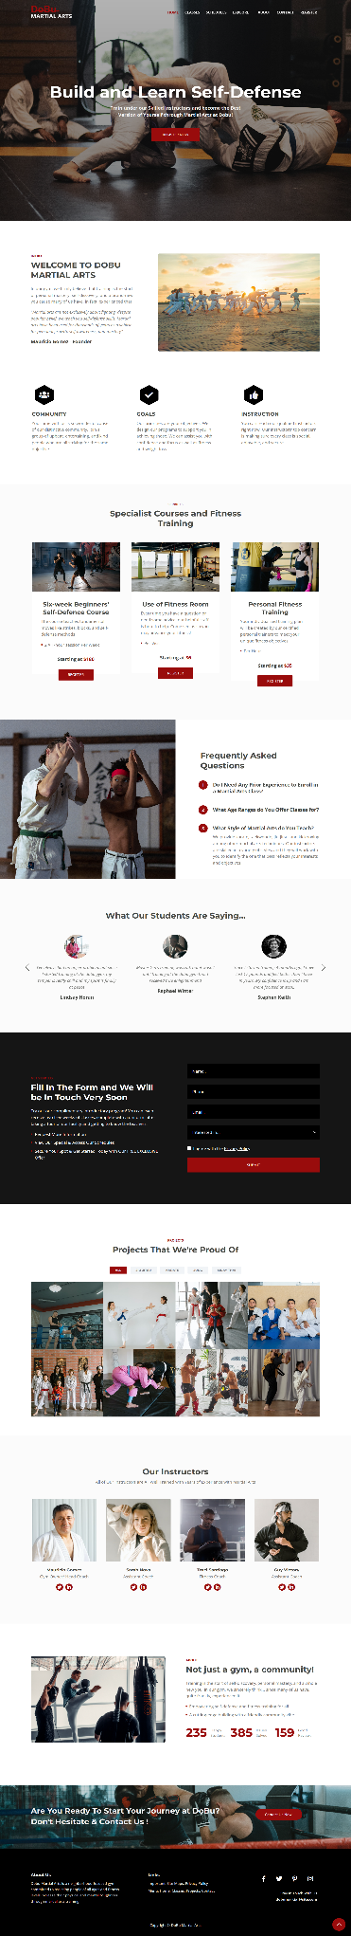

Classes.html

|  |
| --- |
| <!DOCTYPE html>  <html lang="en">      <head>          <meta charset="utf-8">          <meta name="viewport" content="width=device-width, initial-scale=1, shrink-to-fit=no">            <!-- Webpage Title -->          <title>Classes</title>            <!-- Styles -->          <link href="https://fonts.googleapis.com/css2?family=Montserrat:wght@700&family=Open+Sans:ital,wght@0,400;0,700;1,400&display=swap" rel="stylesheet">          <link href="css/bootstrap.min.css" rel="stylesheet">          <link href="css/fontawesome-all.min.css" rel="stylesheet">          <link href="css/swiper.css" rel="stylesheet">          <link href="css/styles.css" rel="stylesheet">          <script src="https://kit.fontawesome.com/f57991b77d.js" crossorigin="anonymous"></script>            <!-- Favicon  -->          <link rel="icon" href="images/favicon.png">      </head>      <body>            <!-- Navigation -->          <nav id="navbarExample" class="navbar navbar-expand-lg fixed-top navbar-dark" aria-label="Main navigation">              <div class="container">                  <!-- Logo -->                  <a href="index.html" class="navbar-brand-logo"> D̶o̶B̶u̶  <p>MARTIAL ARTS</p></a>                  <button class="navbar-toggler p-0 border-0" type="button" id="navbarSideCollapse" aria-label="Toggle navigation">                      <span class="navbar-toggler-icon"></span>                  </button>                  <div class="navbar-collapse offcanvas-collapse" id="navbarsExampleDefault">                      <ul class="navbar-nav ms-auto navbar-nav-scroll">                          <li class="nav-item">                              <a class="nav-link" href="index.html">Home</a>                          </li>                          <li class="nav-item">                              <a class="nav-link" href="classes.html">Classes</a>                          </li>                          <li class="nav-item">                              <a class="nav-link" href="schedules.html">Schedules</a>                          </li>                          <li class="nav-item dropdown">                              <a class="nav-link dropdown-toggle" href="#" id="dropdown01" data-bs-toggle="dropdown" aria-expanded="false">Explore</a>                              <ul class="dropdown-menu" aria-labelledby="dropdown01">                                  <li><a class="dropdown-item" href="sitemap.html">Site Maps</a></li>                                  <li><div class="dropdown-divider"></div></li>                                  <li><a class="dropdown-item" href="privacy.html">Privacy Policy</a></li>                              </ul>                          </li>                          <li class="nav-item">                              <a class="nav-link" href="index.html#about">About</a>                          </li>                          <li class="nav-item">                              <a class="nav-link" href="contact.html">Contact</a>                          </li>                          <li class="nav-item">                              <a class="nav-link" href="index.html#registration">Register</a>                          </li>                      </ul>                    </div>              </div>          </nav>          <!-- end of navigation -->          <!-- Header -->          <header class="ex-header">              <div class="container">                  <div class="row">                      <div class="col-xl-10 offset-xl-1">                          <h1>Classes</h1>                      </div>                  </div>              </div>          </header>          <!-- end of header -->            <section class="section courses" id="courses" >              <div class="container">                  <div class="row event_box">                  <div class="col-lg-4 col-md-6 align-self-center mb-30 event_outer col-md-6">                    <div class="events_item">                      <div class="thumb">                        <a href="#"><img src="images/pexels-rodnae-productions-8611431.jpg" alt=""></a>                        <span class="category">Basic</span>                        <span class="price"><h6><em>£</em>25</h6></span>                      </div>                      <div class="down-content">                        <span class="author">Morris Davis</span>                        <h4>1 martial art – 2 sessions per week</h4>                      </div>                    </div>                  </div>                  <div class="col-lg-4 col-md-6 align-self-center mb-30 event_outer col-md-6  ">                    <div class="events_item">                      <div class="thumb">                        <a href="#"><img src="images/pexels-paris-lopez-9651864.jpg" alt=""></a>                        <span class="category">Intermediate</span>                        <span class="price"><h6><em>£</em>35</h6></span>                      </div>                      <div class="down-content">                        <span class="author">Guy Victory</span>                        <h4>1 martial art – 3 sessions per week</h4>                      </div>                    </div>                  </div>                  <div class="col-lg-4 col-md-6 align-self-center mb-30 event_outer col-md-6 design ">                    <div class="events_item">                      <div class="thumb">                        <a href="#"><img src="images/pexels-rodnae-productions-7045486.jpg" alt=""></a>                        <span class="category">Advanced</span>                        <span class="price"><h6><em>£</em>45</h6></span>                      </div>                      <div class="down-content">                        <span class="author">Sarah Nova</span>                        <h4>any 2 martial arts – 5 sessions per week</h4>                      </div>                    </div>                  </div>                  <div class="col-lg-4 col-md-6 align-self-center mb-30 event_outer col-md-6 ">                    <div class="events_item">                      <div class="thumb">                        <a href="#"><img src="images/pexels-rodnae-productions-7045554.jpg" alt=""></a>                        <span class="category">Elite</span>                        <span class="price"><h6><em>£</em>60</h6></span>                      </div>                      <div class="down-content">                        <span class="author">Mauricio Gomez</span>                        <h4>unlimited martial arts classes</h4>                      </div>                    </div>                  </div>                  <div class="col-lg-4 col-md-6 align-self-center mb-30 event_outer col-md-6 wordpress ">                    <div class="events_item">                      <div class="thumb">                        <a href="#"><img src="images/pexels-rodnae-productions-8611964.jpg" alt=""></a>                        <span class="category">per hour</span>                        <span class="price"><h6><em>£</em>15</h6></span>                      </div>                      <div class="down-content">                        <span class="author">Traci Santiago</span>                        <h4>private martial arts tuition</h4>                      </div>                    </div>                  </div>                  <div class="col-lg-4 col-md-6 align-self-center mb-30 event_outer col-md-6 wordpress ">                    <div class="events_item">                      <div class="thumb">                        <a href="#"><img src="images/pexels-cottonbro-studio-7988769.jpg" alt=""></a>                        <span class="category">Junior</span>                        <span class="price"><h6><em>£</em>25</h6></span>                      </div>                      <div class="down-content">                        <span class="author">Mauricio Gomez</span>                        <h4> all-kids martial arts sessions</h4>                      </div>                    </div>                  </div>                </div>              </div>            </section>              <!-- Footer -->          <div class="footer">            <div class="container">                <div class="row">                    <div class="col-lg-12">                        <div class="footer-col first">                            <h6>About Us</h6>                            <p class="p-small">Dobu Martial Arts is a neighborhood-focused gym committed to                                assisting people of all ages and fitness levels increase their physical and mental toughness through martial arts training</p>                        </div>                        <div class="footer-col second">                            <h6>Links</h6>                            <ul class="list-unstyled li-space-lg p-small">                                <li>Important: <a href="sitemap.html">Site Maps</a>, <a href="privacy.html">Privacy Policy</a></li>                                <li>Menu: <a href="index.html#header">Home</a>, <a href="classes.html">Classes</a>, <a href="index.html#projects">Projects</a>, <a href="contact.html">Contact</a></li>                            </ul>                        </div>                        <div class="footer-col third">                            <span class="fa-stack">                                <a href="https://www.facebook.com/">                                    <i class="fab fa-facebook-f fa-stack-1x"></i>                                </a>                            </span>                            <span class="fa-stack">                                <a href="https://twitter.com/login">                                    <i class="fab fa-twitter fa-stack-1x"></i>                                </a>                            </span>                            <span class="fa-stack">                                <a href="https://www.pinterest.com/">                                    <i class="fab fa-pinterest-p fa-stack-1x"></i>                                </a>                            </span>                            <span class="fa-stack">                                <a href="https://www.instagram.com/">                                    <i class="fab fa-instagram fa-stack-1x"></i>                                </a>                            </span>                            <p class="p-small">Stay In Touch With Us <a href="mailto:dobumartial@site.com"><strong>dobumartial@site.com</strong></a></p>                        </div>                    </div>                </div>            </div>        </div>        <!-- end of footer -->        <!-- Copyright -->        <div class="copyright">            <div class="container">                <div class="row">                    <div class="col-lg-12">                        <p class="p-small">Copyright © DoBu Martial Arts</p>                    </div>                </div>            </div>        </div>        <!-- end of copyright -->          <!-- Back To Top Button -->          <button onclick="topFunction()" id="myBtn">              <img src="images/up-arrow.png" alt="alternative">          </button>          <!-- end of back to top button -->            <!-- Scripts -->          <script src="js/bootstrap.min.js"></script>          <script src="js/swiper.min.js"></script>          <script src="js/purecounter.min.js"></script>          <script src="js/replaceme.min.js"></script>          <script src="js/isotope.pkgd.min.js"></script>          <script src="js/scripts.js"></script>      </body>  </html> |

Classes Page

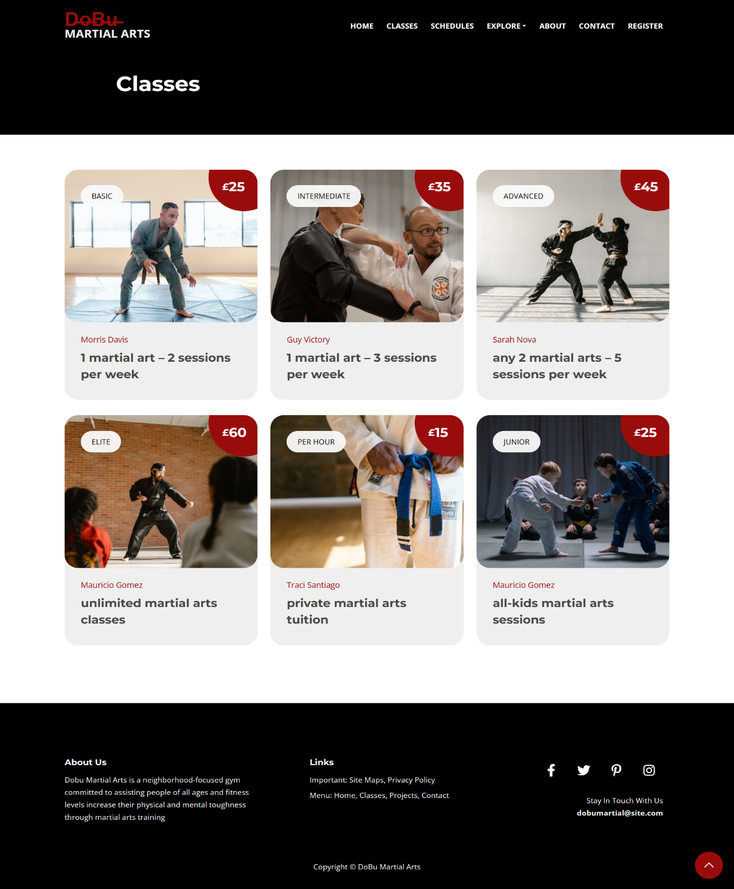

Schedules.html

|  |
| --- |
| <!DOCTYPE html>  <html lang="en">      <head>          <meta charset="utf-8">          <meta name="viewport" content="width=device-width, initial-scale=1, shrink-to-fit=no">            <!-- Webpage Title -->          <title>Schedules</title>            <!-- Styles -->          <link href="https://fonts.googleapis.com/css2?family=Montserrat:wght@700&family=Open+Sans:ital,wght@0,400;0,700;1,400&display=swap" rel="stylesheet">          <link href="css/bootstrap.min.css" rel="stylesheet">          <link href="css/fontawesome-all.min.css" rel="stylesheet">          <link href="css/swiper.css" rel="stylesheet">          <link href="css/styles.css" rel="stylesheet">          <script src="https://kit.fontawesome.com/f57991b77d.js" crossorigin="anonymous"></script>              <!-- Favicon  -->          <link rel="icon" href="images/favicon.png">      </head>      <body data-bs-spy="scroll" data-bs-target="#navbarExample">            <!-- Navigation -->          <nav id="navbarExample" class="navbar navbar-expand-lg fixed-top navbar-dark" aria-label="Main navigation">              <div class="container">                  <!-- Logo -->                  <a href="index.html" class="navbar-brand-logo"> D̶o̶B̶u̶  <p>MARTIAL ARTS</p></a>                  <button class="navbar-toggler p-0 border-0" type="button" id="navbarSideCollapse" aria-label="Toggle navigation">                      <span class="navbar-toggler-icon"></span>                  </button>                  <div class="navbar-collapse offcanvas-collapse" id="navbarsExampleDefault">                      <ul class="navbar-nav ms-auto navbar-nav-scroll">                          <li class="nav-item">                              <a class="nav-link" href="index.html">Home</a>                          </li>                          <li class="nav-item">                              <a class="nav-link" href="classes.html">Classes</a>                          </li>                          <li class="nav-item">                              <a class="nav-link" href="schedules.html">Schedules</a>                          </li>                          <li class="nav-item dropdown">                              <a class="nav-link dropdown-toggle" href="#" id="dropdown01" data-bs-toggle="dropdown" aria-expanded="false">Explore</a>                              <ul class="dropdown-menu" aria-labelledby="dropdown01">                                  <li><a class="dropdown-item" href="sitemap.html">Site Maps</a></li>                                  <li><div class="dropdown-divider"></div></li>                                  <li><a class="dropdown-item" href="privacy.html">Privacy Policy</a></li>                              </ul>                          </li>                          <li class="nav-item">                              <a class="nav-link" href="index.html#about">About</a>                          </li>                          <li class="nav-item">                              <a class="nav-link" href="contact.html">Contact</a>                          </li>                          <li class="nav-item">                              <a class="nav-link" href="index.html#registration">Register</a>                          </li>                      </ul>                    </div> <!-- end of navbar-collapse -->              </div> <!-- end of container -->          </nav> <!-- end of navbar -->          <!-- end of navigation -->          <!-- Header -->          <header class="ex-header">              <div class="container">                  <div class="row">                      <div class="col-xl-10 offset-xl-1">                          <h1>Schedules</h1>                      </div> <!-- end of col -->                  </div> <!-- end of row -->              </div> <!-- end of container -->          </header> <!-- end of ex-header -->          <!-- end of header -->            <div class="col-lg-9">              <div class="image-container">                  <img class="img-fluid" src="images/timetable.jpg" alt="alternative" >              </div>          </div>            <!-- Footer -->          <div class="footer">              <div class="container">                  <div class="row">                      <div class="col-lg-12">                          <div class="footer-col first">                              <h6>About Us</h6>                              <p class="p-small">Dobu Martial Arts is a neighborhood-focused gym committed to                                  assisting people of all ages and fitness levels increase their physical and mental toughness through martial arts training</p>                          </div> <!-- end of footer-col -->                          <div class="footer-col second">                              <h6>Links</h6>                              <ul class="list-unstyled li-space-lg p-small">                                  <li>Important: <a href="sitemap.html">Site Maps</a>, <a href="privacy.html">Privacy Policy</a></li>                                  <li>Menu: <a href="index.html#header">Home</a>, <a href="classes.html">Classes</a>, <a href="index.html#projects">Projects</a>, <a href="contact.html">Contact</a></li>                              </ul>                          </div> <!-- end of footer-col -->                          <div class="footer-col third">                              <span class="fa-stack">                                  <a href="https://www.facebook.com/">                                      <i class="fab fa-facebook-f fa-stack-1x"></i>                                  </a>                              </span>                              <span class="fa-stack">                                  <a href="https://twitter.com/login">                                      <i class="fab fa-twitter fa-stack-1x"></i>                                  </a>                              </span>                              <span class="fa-stack">                                  <a href="https://www.pinterest.com/">                                      <i class="fab fa-pinterest-p fa-stack-1x"></i>                                  </a>                              </span>                              <span class="fa-stack">                                  <a href="https://www.instagram.com/">                                      <i class="fab fa-instagram fa-stack-1x"></i>                                  </a>                              </span>                              <p class="p-small">Stay In Touch With Us <a href="mailto:dobumartial@site.com"><strong>dobumartial@site.com</strong></a></p>                          </div> <!-- end of footer-col -->                      </div> <!-- end of col -->                  </div> <!-- end of row -->              </div> <!-- end of container -->          </div> <!-- end of footer -->          <!-- end of footer -->          <!-- Copyright -->          <div class="copyright">              <div class="container">                  <div class="row">                      <div class="col-lg-12">                          <p class="p-small">Copyright © DoBu Martial Arts</p>                      </div> <!-- end of col -->                  </div> <!-- enf of row -->              </div> <!-- end of container -->          </div> <!-- end of copyright -->          <!-- end of copyright -->            <!-- Back To Top Button -->          <button onclick="topFunction()" id="myBtn">              <img src="images/up-arrow.png" alt="alternative">          </button>          <!-- end of back to top button -->            <!-- Scripts -->          <script src="js/bootstrap.min.js"></script>          <script src="js/swiper.min.js"></script>          <script src="js/purecounter.min.js"></script>          <script src="js/replaceme.min.js"></script>          <script src="js/isotope.pkgd.min.js"></script>          <script src="js/scripts.js"></script>      </body>  </html> |

Schedules Page

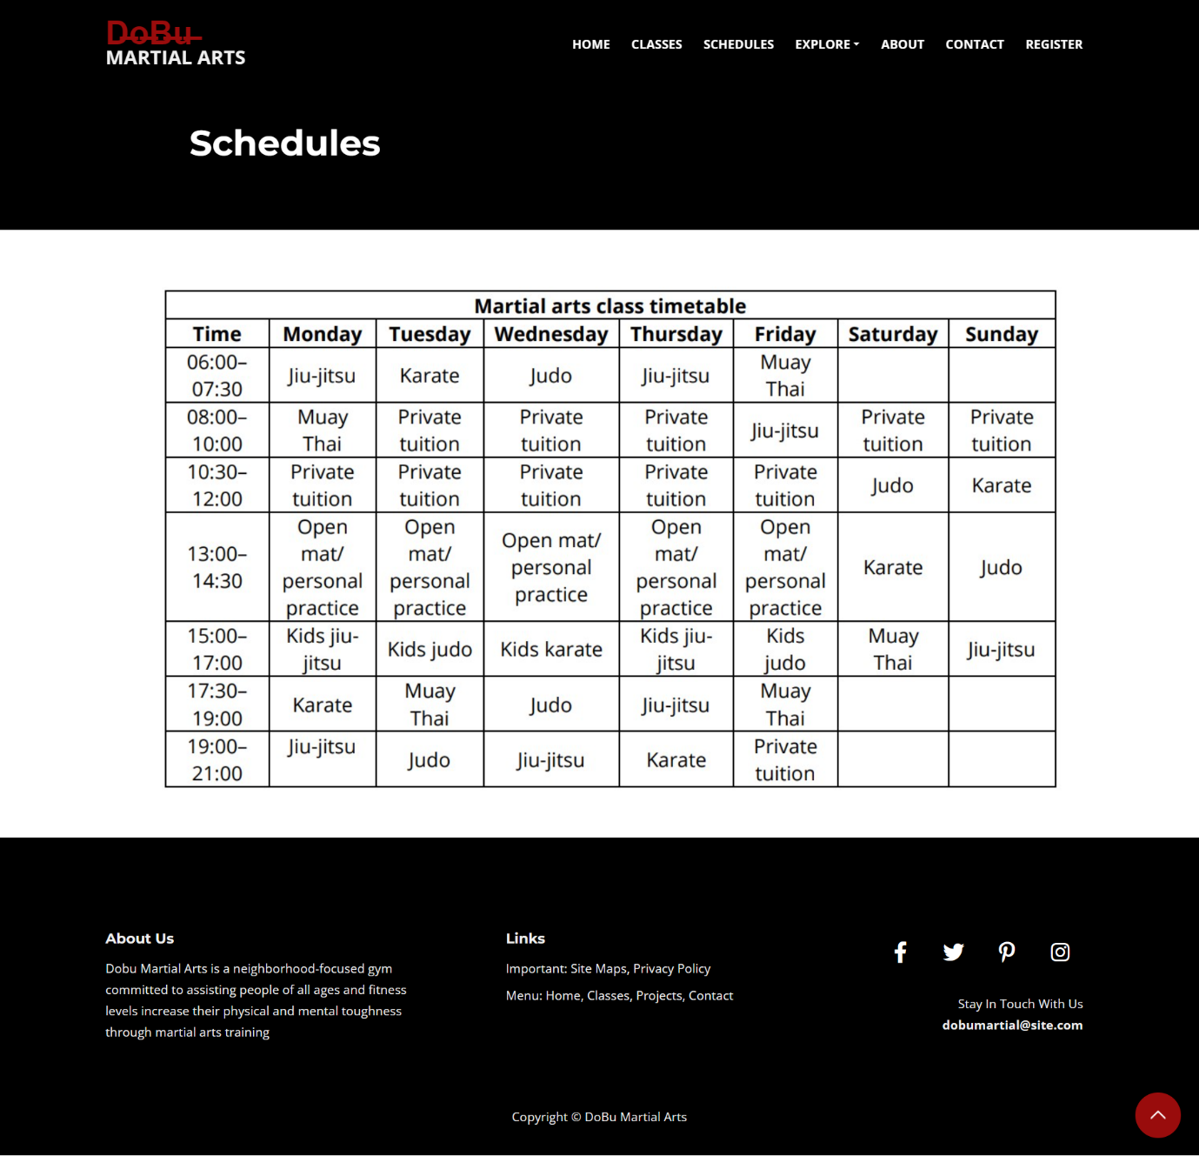

Contact.html

|  |
| --- |
| <!DOCTYPE html>  <html lang="en">      <head>          <meta charset="utf-8">          <meta name="viewport" content="width=device-width, initial-scale=1, shrink-to-fit=no">            <!-- Webpage Title -->          <title>Contact Us</title>            <!-- Styles -->          <link href="https://fonts.googleapis.com/css2?family=Montserrat:wght@700&family=Open+Sans:ital,wght@0,400;0,700;1,400&display=swap" rel="stylesheet">          <link href="css/bootstrap.min.css" rel="stylesheet">          <link href="css/fontawesome-all.min.css" rel="stylesheet">          <link href="css/swiper.css" rel="stylesheet">          <link href="css/styles.css" rel="stylesheet">          <script src="https://kit.fontawesome.com/f57991b77d.js" crossorigin="anonymous"></script>            <!-- Favicon  -->          <link rel="icon" href="images/favicon.png">      </head>      <body>            <!-- Navigation -->          <nav id="navbarExample" class="navbar navbar-expand-lg fixed-top navbar-dark" aria-label="Main navigation">              <div class="container">                  <!-- Logo -->                  <a href="index.html" class="navbar-brand-logo"> D̶o̶B̶u̶  <p>MARTIAL ARTS</p></a>                  <button class="navbar-toggler p-0 border-0" type="button" id="navbarSideCollapse" aria-label="Toggle navigation">                      <span class="navbar-toggler-icon"></span>                  </button>                  <div class="navbar-collapse offcanvas-collapse" id="navbarsExampleDefault">                      <ul class="navbar-nav ms-auto navbar-nav-scroll">                          <li class="nav-item">                              <a class="nav-link" href="index.html">Home</a>                          </li>                          <li class="nav-item">                              <a class="nav-link" href="classes.html">Classes</a>                          </li>                          <li class="nav-item">                              <a class="nav-link" href="schedules.html">Schedules</a>                          </li>                          <li class="nav-item dropdown">                              <a class="nav-link dropdown-toggle" href="#" id="dropdown01" data-bs-toggle="dropdown" aria-expanded="false">Explore</a>                              <ul class="dropdown-menu" aria-labelledby="dropdown01">                                  <li><a class="dropdown-item" href="sitemap.html">Site Maps</a></li>                                  <li><div class="dropdown-divider"></div></li>                                  <li><a class="dropdown-item" href="privacy.html">Privacy Policy</a></li>                              </ul>                          </li>                          <li class="nav-item">                              <a class="nav-link" href="index.html#about">About</a>                          </li>                          <li class="nav-item">                              <a class="nav-link" href="contact.html">Contact</a>                          </li>                          <li class="nav-item">                              <a class="nav-link" href="index.html#registration">Register</a>                          </li>                      </ul>                    </div>              </div>          </nav>          <!-- end of navigation -->          <!-- Header -->          <header class="ex-header">              <div class="container">                  <div class="row">                      <div class="col-xl-10 offset-xl-1">                          <h1>Contact Us!</h1>                      </div>                  </div>              </div>          </header>          <!-- end of header -->            <section class="contact-us">              <div class="container">                <div class="row">                    <div class="col-lg-12">                    <div class="down-contact">                      <div class="row">                        <div class="col-lg-8">                          <div class="sidebar-item contact-form">                            <div class="sidebar-heading">                              <h2>Send us a message</h2>                            </div>                            <div class="content">                              <form id="contact" action="" method="post">                                <div class="row">                                  <div class="col-md-6 col-sm-12">                                    <fieldset>                                      <input name="name" type="text" id="name" placeholder="Your name.." required="">                                    </fieldset>                                  </div>                                  <div class="col-md-6 col-sm-12">                                    <fieldset>                                      <input name="email" type="text" id="email" placeholder="Your email.." required="">                                    </fieldset>                                  </div>                                  <div class="col-md-12 col-sm-12">                                    <fieldset>                                      <input name="subject" type="text" id="subject" placeholder="Class..">                                    </fieldset>                                  </div>                                  <div class="col-lg-12">                                    <fieldset>                                      <textarea name="message" rows="6" id="message" placeholder="Your Message.." required=""></textarea>                                    </fieldset>                                  </div>                                  <div class="col-lg-12">                                    <fieldset>                                      <button type="submit" id="form-submit" class="main-button">Send Message</button>                                    </fieldset>                                  </div>                                </div>                              </form>                            </div>                          </div>                        </div>                        <div class="col-lg-4">                          <div class="sidebar-item contact-information">                            <div class="sidebar-heading">                              <h2>contact information</h2>                            </div>                            <div class="content">                              <ul>                                <li>                                  <h5>090-755-9630</h5>                                  <span>PHONE NUMBER</span>                                </li>                                <li>                                  <h5>dobumartialarts.com</h5>                                  <span>EMAIL ADDRESS</span>                                </li>                                <li>                                  <h5>5550 Dooley Wells, Suite 617, Kutchstad, Michigan,                                      <br>United States</h5>                                  <span>STREET ADDRESS</span>                                </li>                              </ul>                            </div>                          </div>                        </div>                      </div>                    </div>                  </div>                    <div class="col-lg-12">                    <div id="map">                      <iframe src="https://maps.google.com/maps?q=Av.+L%C3%BAcio+Costa,+Rio+de+Janeiro+-+RJ,+Brazil&t=&z=13&ie=UTF8&iwloc=&output=embed"                      width="100%" height="450px" frameborder="0" style="border:0" allowfullscreen></iframe>                    </div>                  </div>                  </div>              </div>            </section>              <!-- Footer -->          <div class="footer">            <div class="container">                <div class="row">                    <div class="col-lg-12">                        <div class="footer-col first">                            <h6>About Us</h6>                            <p class="p-small">Dobu Martial Arts is a neighborhood-focused gym committed to                                assisting people of all ages and fitness levels increase their physical and mental toughness through martial arts training</p>                        </div>                        <div class="footer-col second">                            <h6>Links</h6>                            <ul class="list-unstyled li-space-lg p-small">                                <li>Important: <a href="sitemap.html">Site Maps</a>, <a href="privacy.html">Privacy Policy</a></li>                                <li>Menu: <a href="index.html#header">Home</a>, <a href="classes.html">Classes</a>, <a href="index.html#projects">Projects</a>, <a href="contact.html">Contact</a></li>                            </ul>                        </div>                        <div class="footer-col third">                            <span class="fa-stack">                                <a href="https://www.facebook.com/">                                    <i class="fab fa-facebook-f fa-stack-1x"></i>                                </a>                            </span>                            <span class="fa-stack">                                <a href="https://twitter.com/login">                                    <i class="fab fa-twitter fa-stack-1x"></i>                                </a>                            </span>                            <span class="fa-stack">                                <a href="https://www.pinterest.com/">                                    <i class="fab fa-pinterest-p fa-stack-1x"></i>                                </a>                            </span>                            <span class="fa-stack">                                <a href="https://www.instagram.com/">                                    <i class="fab fa-instagram fa-stack-1x"></i>                                </a>                            </span>                            <p class="p-small">Stay In Touch With Us <a href="mailto:dobumartial@site.com"><strong>dobumartial@site.com</strong></a></p>                        </div>                    </div>                </div>            </div>        </div>        <!-- end of footer -->        <!-- Copyright -->        <div class="copyright">            <div class="container">                <div class="row">                    <div class="col-lg-12">                        <p class="p-small">Copyright © DoBu Martial Arts</p>                    </div>                </div>            </div>        </div>        <!-- end of copyright -->            <!-- Back To Top Button -->          <button onclick="topFunction()" id="myBtn">              <img src="images/up-arrow.png" alt="alternative">          </button>          <!-- end of back to top button -->            <!-- Scripts -->          <script src="js/bootstrap.min.js"></script>          <script src="js/swiper.min.js"></script>          <script src="js/purecounter.min.js"></script>          <script src="js/replaceme.min.js"></script>          <script src="js/isotope.pkgd.min.js"></script>          <script src="js/scripts.js"></script>          <script language = "text/Javascript">              cleared[0] = cleared[1] = cleared[2] = 0; //set a cleared flag for each field              function clearField(t){                   //declaring the array outside of the              if(! cleared[t.id]){                      // function makes it static and global                  cleared[t.id] = 1;  // you could use true and false, but that's more typing                  t.value='';         // with more chance of typos                  t.style.color='#fff';                  }              }            </script>      </body>  </html> |

Contact Us Page

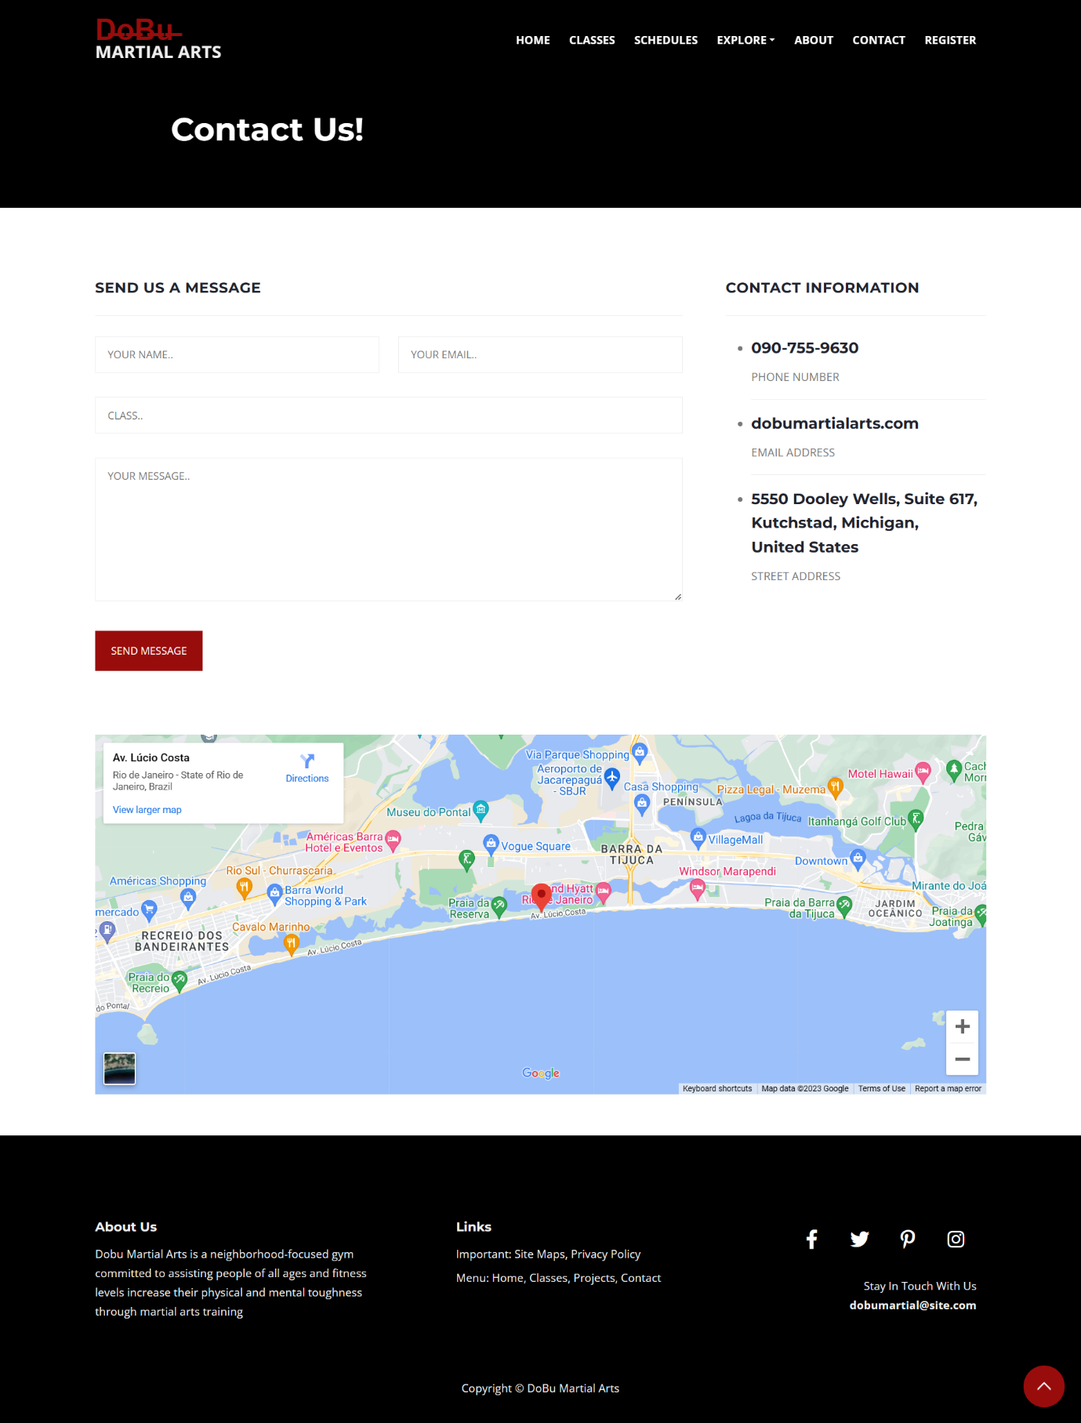

Sitemap.html

|  |
| --- |
| <!DOCTYPE html>  <html lang="en">      <head>          <meta charset="utf-8">          <meta name="viewport" content="width=device-width, initial-scale=1, shrink-to-fit=no">            <!-- Webpage Title -->          <title>Site Maps</title>            <!-- Styles -->          <link href="https://fonts.googleapis.com/css2?family=Montserrat:wght@700&family=Open+Sans:ital,wght@0,400;0,700;1,400&display=swap" rel="stylesheet">          <link href="css/bootstrap.min.css" rel="stylesheet">          <link href="css/fontawesome-all.min.css" rel="stylesheet">          <link href="css/swiper.css" rel="stylesheet">          <link href="css/styles.css" rel="stylesheet">          <script src="https://kit.fontawesome.com/f57991b77d.js" crossorigin="anonymous"></script>            <!-- Favicon  -->          <link rel="icon" href="images/favicon.png">      </head>      <body>            <!-- Navigation -->          <nav id="navbarExample" class="navbar navbar-expand-lg fixed-top navbar-dark" aria-label="Main navigation">              <div class="container">                  <!-- Logo -->                  <a href="index.html" class="navbar-brand-logo"> D̶o̶B̶u̶  <p>MARTIAL ARTS</p></a>                  <button class="navbar-toggler p-0 border-0" type="button" id="navbarSideCollapse" aria-label="Toggle navigation">                      <span class="navbar-toggler-icon"></span>                  </button>                  <div class="navbar-collapse offcanvas-collapse" id="navbarsExampleDefault">                      <ul class="navbar-nav ms-auto navbar-nav-scroll">                          <li class="nav-item">                              <a class="nav-link" href="index.html">Home</a>                          </li>                          <li class="nav-item">                              <a class="nav-link" href="classes.html">Classes</a>                          </li>                          <li class="nav-item">                              <a class="nav-link" href="schedules.html">Schedules</a>                          </li>                          <li class="nav-item dropdown">                              <a class="nav-link dropdown-toggle" href="#" id="dropdown01" data-bs-toggle="dropdown" aria-expanded="false">Explore</a>                              <ul class="dropdown-menu" aria-labelledby="dropdown01">                                  <li><a class="dropdown-item" href="sitemap.html">Site Maps</a></li>                                  <li><div class="dropdown-divider"></div></li>                                  <li><a class="dropdown-item" href="privacy.html">Privacy Policy</a></li>                              </ul>                          </li>                          <li class="nav-item">                              <a class="nav-link" href="index.html#about">About</a>                          </li>                          <li class="nav-item">                              <a class="nav-link" href="contact.html">Contact</a>                          </li>                          <li class="nav-item">                              <a class="nav-link" href="index.html#registration">Register</a>                          </li>                      </ul>                    </div>              </div>          </nav>          <!-- end of navigation -->          <!-- Header -->          <header class="ex-header">              <div class="container">                  <div class="row">                      <div class="col-xl-10 offset-xl-1">                          <h1>Site Map</h1>                      </div>                  </div>              </div>          </header>          <!-- end of header -->            <main id="main-content" name="main-content" class="" tabindex="-1" aria-label="Content">                <div class="site-map"><div class="container mw-lg py-4"><h1 class="h2 pt-2"> DoBu Martial Arts Site Map</h1><hr class="hr">                  <div class="row"><div class="col-12 col-sm-6 col-md-4"><h2 class="h3 mb-3">About DoBu</h2><ul class="list-unstyled p-0">                    <li><a class="muted-link" href="index.html#about" __tracked="true">About</a></li>                    <li><a class="muted-link" href="classes.html" __tracked="true">Classes</a></li>                    <li><a class="muted-link" href="schedules.html" __tracked="true">Schedules</a></li>                    <li><a class="muted-link" href="sitemap.html" __tracked="true">Site Map</a></li>                    <li><a class="muted-link" href="privacy.html" __tracked="true">Privacy Policy</a></li>                    <li><a class="muted-link" href="contact.html" __tracked="true">Contact Us</a></li></ul>                    <h2 class="h3 mb-3">Resources</h2><ul class="list-unstyled p-0">                    <li><a class="muted-link" href="index.html#faq" __tracked="true">FAQs</a></li>                    <li><a class="muted-link" href="index.html#registration" __tracked="true">Register</a></li>                    <li><a class="muted-link" href="index.html" __tracked="true">Home</a></li></ul></div>                    <div class="col-12 col-sm-6 col-md-4 d-sm-none d-md-block"><h2 class="h3 mb-3">Classes</h2>                      <ul class="list-unstyled p-0"><li><a class="muted-link" href="classes.html" __tracked="true">Jiu-Jitsu </a></li>                        <li><a class="muted-link" href="classes.html" __tracked="true">Karate</a></li>                        <li><a class="muted-link" href="classes.html" __tracked="true">Judo</a></li>                        <li><a class="muted-link" href="classes.html" __tracked="true">Muay Thai</a></li>                        <li><a class="muted-link" href="classes.html" __tracked="true">Kids Sessions</a></li>                            </ul></div>                        <div class="col-12 col-sm-6 col-md-4"><h2 class="h3 mb-3">Connect</h2><ul class="list-unstyled p-0">                          <li><a class="muted-link" href="contact.html" __tracked="true">Contact Us</a></li>                          <li><a class="muted-link" href="index.html#projects" __tracked="true">Projects</a></li>                          </ul><h2 class="h3 mb-3">Legal</h2>                          <ul class="list-unstyled p-0"><li><a class="muted-link" href="privacy.html" __tracked="true">Privacy Policy</a></li>                            <li><a class="muted-link" href="sitemap.html" __tracked="true">Sitemap</a></li>                          </ul>                          <h2 class="h3 mb-3">Social</h2>                            <ul class="list-unstyled p-0"><li><a class="muted-link" href="https://www.facebook.com/" __tracked="true">DuBo Facebook</a></li>                              <li><a class="muted-link" href="https://twitter.com/login" __tracked="true">DuBo Twitter</a></li>                              <li><a class="muted-link" href="https://www.instagram.com/" __tracked="true">DuBo Instagram</a></li>                  </ul>                </div>                </div>                </div>                </div>                </main>                <!-- Footer -->          <div class="footer">              <div class="container">                  <div class="row">                      <div class="col-lg-12">                          <div class="footer-col first">                              <h6>About Us</h6>                              <p class="p-small">Dobu Martial Arts is a neighborhood-focused gym committed to                                  assisting people of all ages and fitness levels increase their physical and mental toughness through martial arts training</p>                          </div>                          <div class="footer-col second">                              <h6>Links</h6>                              <ul class="list-unstyled li-space-lg p-small">                                  <li>Important: <a href="sitemap.html">Site Maps</a>, <a href="privacy.html">Privacy Policy</a></li>                                  <li>Menu: <a href="index.html#header">Home</a>, <a href="classes.html">Classes</a>, <a href="index.html#projects">Projects</a>, <a href="contact.html">Contact</a></li>                              </ul>                          </div>                          <div class="footer-col third">                              <span class="fa-stack">                                  <a href="https://www.facebook.com/">                                      <i class="fab fa-facebook-f fa-stack-1x"></i>                                  </a>                              </span>                              <span class="fa-stack">                                  <a href="https://twitter.com/login">                                      <i class="fab fa-twitter fa-stack-1x"></i>                                  </a>                              </span>                              <span class="fa-stack">                                  <a href="https://www.pinterest.com/">                                      <i class="fab fa-pinterest-p fa-stack-1x"></i>                                  </a>                              </span>                              <span class="fa-stack">                                  <a href="https://www.instagram.com/">                                      <i class="fab fa-instagram fa-stack-1x"></i>                                  </a>                              </span>                              <p class="p-small">Stay In Touch With Us <a href="mailto:dobumartial@site.com"><strong>dobumartial@site.com</strong></a></p>                          </div>                      </div>                  </div>              </div>          </div>          <!-- end of footer -->          <!-- Copyright -->          <div class="copyright">              <div class="container">                  <div class="row">                      <div class="col-lg-12">                          <p class="p-small">Copyright © DoBu Martial Arts</p>                      </div>                  </div>              </div>          </div>          <!-- end of copyright -->            <!-- Back To Top Button -->          <button onclick="topFunction()" id="myBtn">              <img src="images/up-arrow.png" alt="alternative">          </button>          <!-- end of back to top button -->            <!-- Scripts -->          <script src="js/bootstrap.min.js"></script>          <script src="js/swiper.min.js"></script>          <script src="js/purecounter.min.js"></script>          <script src="js/replaceme.min.js"></script>          <script src="js/isotope.pkgd.min.js"></script>          <script src="js/scripts.js"></script>      </body>  </html> |

Site Map Page

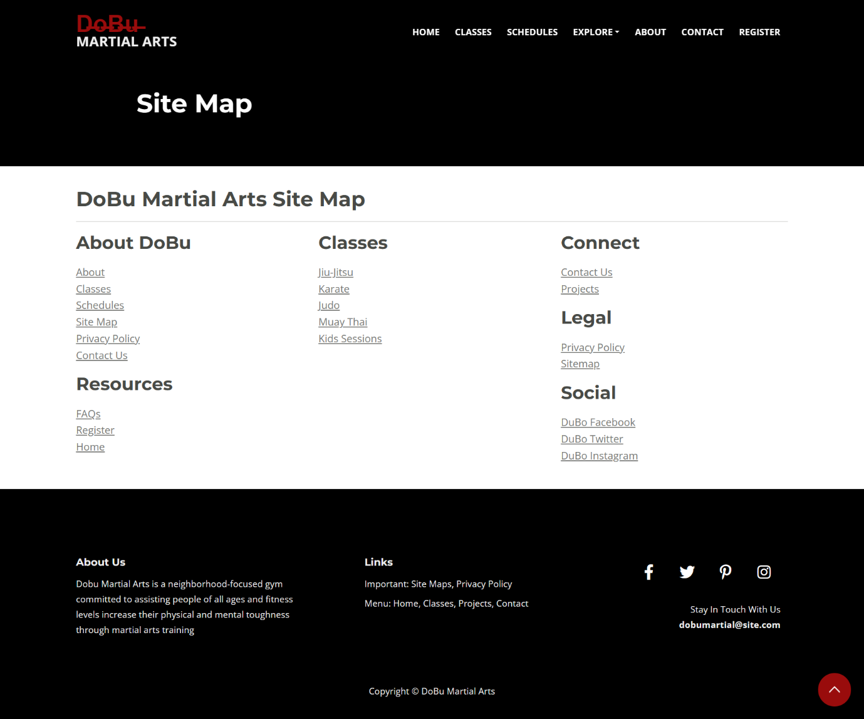

Privacy.html

|  |
| --- |
| <!DOCTYPE html>  <html lang="en">      <head>          <meta charset="utf-8">          <meta name="viewport" content="width=device-width, initial-scale=1, shrink-to-fit=no">            <!-- Webpage Title -->          <title>Privacy Policy</title>            <!-- Styles -->          <link href="https://fonts.googleapis.com/css2?family=Montserrat:wght@700&family=Open+Sans:ital,wght@0,400;0,700;1,400&display=swap" rel="stylesheet">          <link href="css/bootstrap.min.css" rel="stylesheet">          <link href="css/fontawesome-all.min.css" rel="stylesheet">          <link href="css/swiper.css" rel="stylesheet">          <link href="css/styles.css" rel="stylesheet">          <script src="https://kit.fontawesome.com/f57991b77d.js" crossorigin="anonymous"></script>            <!-- Favicon  -->          <link rel="icon" href="images/favicon.png">      </head>      <body>            <!-- Navigation -->          <nav id="navbarExample" class="navbar navbar-expand-lg fixed-top navbar-dark" aria-label="Main navigation">              <div class="container">                  <!-- Logo -->                  <a href="index.html" class="navbar-brand-logo"> D̶o̶B̶u̶  <p>MARTIAL ARTS</p></a>                  <button class="navbar-toggler p-0 border-0" type="button" id="navbarSideCollapse" aria-label="Toggle navigation">                      <span class="navbar-toggler-icon"></span>                  </button>                  <div class="navbar-collapse offcanvas-collapse" id="navbarsExampleDefault">                      <ul class="navbar-nav ms-auto navbar-nav-scroll">                          <li class="nav-item">                              <a class="nav-link" href="index.html">Home</a>                          </li>                          <li class="nav-item">                              <a class="nav-link" href="classes.html">Classes</a>                          </li>                          <li class="nav-item">                              <a class="nav-link" href="schedules.html">Schedules</a>                          </li>                          <li class="nav-item dropdown">                              <a class="nav-link dropdown-toggle" href="#" id="dropdown01" data-bs-toggle="dropdown" aria-expanded="false">Explore</a>                              <ul class="dropdown-menu" aria-labelledby="dropdown01">                                  <li><a class="dropdown-item" href="sitemap.html">Site Maps</a></li>                                  <li><div class="dropdown-divider"></div></li>                                  <li><a class="dropdown-item" href="privacy.html">Privacy Policy</a></li>                              </ul>                          </li>                          <li class="nav-item">                              <a class="nav-link" href="index.html#about">About</a>                          </li>                          <li class="nav-item">                              <a class="nav-link" href="contact.html">Contact</a>                          </li>                          <li class="nav-item">                              <a class="nav-link" href="index.html#registration">Register</a>                          </li>                      </ul>                    </div>              </div>          </nav>          <!-- end of navigation -->          <!-- Header -->          <header class="ex-header">              <div class="container">                  <div class="row">                      <div class="col-xl-10 offset-xl-1">                          <h1>Privacy Policy</h1>                      </div>                  </div>              </div>          </header>          <!-- end of header -->          <!-- Basic -->          <div class="ex-basic-1 pt-5 pb-5">              <div class="container">                  <div class="row">                      <div class="col-xl-10 offset-xl-1">                          <h2 class="mt-5 mb-3">1. Welcome To Dobu Martial Arts!</h2>                          <p class="mb-5">The protection of your personal information is important to us at Dobu Martial Arts, and we are committed to protecting your privacy. How we gather, utilize, and safeguard the personal data we get from you is described in this privacy statement.</p>                          <h3>1.1. Collection of Personal Information</h3>                          <p class="mb-5">When you register for our services or buy something from our website, we might ask for personal information from you like your name, email address, phone number, and payment information. While you use our website, we may also gather data about your usage, including your IP address and online surfing patterns.</p>                          <h3>1.2. Use of Personal Information</h3>                          <p class="mb-5">We may use the personal information we collect from you to provide you with our services, process your payments, communicate with you, and improve our website and services. We may also use your information to send you marketing communications and promotional offers.</p>                            <h2 class="mb-3">2. Personal Information Provided by You</h2>                          <p>We employ the data we gather to deliver our services to you, handle payments, and get in touch with you regarding our programs and special offers. Your information might also be used to enhance our services and tailor the website experience for you.</p>                          <p class="mb-4">Depending on the context of your interactions with us and the Services, your decisions, and the products and features you use, we may gather personal information from you. We might gather the following types of personal data:</p>                          <ul class="list-unstyled li-space-lg mb-4">                              <li class="d-flex">                                  <i class="fas fa-square"></i>                                  <div class="flex-grow-1"><strong>First and Last Name/Surname:</strong> is to personalize our communication with our users. By collecting names, we can address our users by their first name and make our interactions more personal.</div>                              </li>                              <li class="d-flex">                                  <i class="fas fa-square"></i>                                  <div class="flex-grow-1"><strong>Email Address:</strong> is for communication purposes, to send important updates, notifications, and other relevant information to our users. We may also use email addresses to respond to inquiries and support requests, and to send marketing or promotional messages with the user's consent.</div>                              </li>                              <li class="d-flex">                                  <i class="fas fa-square"></i>                                  <div class="flex-grow-1"><strong>Phone Number:</strong> is used to communicate with users about the classes or services they've expressed interest in. You can use it to get in touch with them to arrange lessons, inform them of schedule changes, or make other important announcements.</div>                              </li>                          </ul>                          <p class="mb-5">You may also have the option to add more information to your public profile, such as a location, social media links, and an about section, which we store along with the other information that we collect.</p>                          <div class="text-box mb-5">                              <h3>DoBu Members</h3>                              <p>On DoBu, a subscriber or purchase is referred to as a member, and in exchange, they could get special treatment from the artists they love. As a member, you must provide your payment information to our payment partners. You may check the privacy policies for these payment partners on the Adyen, Venmo, Apple, PayPal, Stripe, and Checkout websites.</p>                          </div> <!-- end of text-box -->                            <h2 class="mb-3">3. Protection of Personal Information</h2>                          <p class="mb-5"> We take appropriate measures to protect your personal information from unauthorized access, use, or disclosure. We use SSL encryption to secure your payment information, and we regularly monitor our systems for potential security threats.</p>                          <h3>3.1. Disclosure of Personal Information</h3>                          <p class="mb-5">We do not sell or rent your personal information to third parties. However, we may share your information with our service providers and business partners who help us provide our services to you. We may also disclose your information if required by law or in connection with a legal claim or investigation.</p>                          <h3>3.2. Updates to Privacy Policy</h3>                          <p class="mb-5">We may update this Privacy Policy from time to time. The updated policy will be posted on our website with the effective date. We encourage you to review this policy periodically to stay informed about our practices.</p>                          <div class="text-box mb-5">                              <ul class="list-unstyled li-space-lg">                                  <li class="d-flex">                                      <i class="fas fa-square"></i>                                      <div class="flex-grow-1"><strong>Consent</strong> if you have granted us approval to use your personal information for a certain purpose, we may process your information. Your permission is revocable at any time.</div>                                  </li>                                  <li class="d-flex">                                      <i class="fas fa-square"></i>                                      <div class="flex-grow-1"><strong>Legal Obligation</strong> we may process your information if we believe it is necessary to comply with our legal duties in relation to collaborating with law enforcement or other governmental authorities, claiming or defending our legal rights, or presenting your information as evidence in a litigation in which we are involved.</div>                                  </li>                                  <li class="d-flex">                                      <i class="fas fa-square"></i>                                      <div class="flex-grow-1"><strong>Vital Interests</strong> when we feel it is necessary to protect your vital interests or the vital interests of another party, such as when there are potential threats to anyone's safety, we may handle your information.</div>                                  </li>                                  <li class="d-flex">                                      <i class="fas fa-square"></i>                                      <div class="flex-grow-1"><strong>Business Transfers</strong> we might share or transfer your information if there are discussions about a merger, the sale of corporate assets, financing, or the purchase of all or a portion of our business by another company.</div>                                  </li>                                </ul>                          </div> <!-- end of text-box -->                            <h2 class="mb-3">4. Information Shared with Third Parties</h2>                          <p class="mb-4">We never sell your information to third parties. Other than information that is shared with creators or shared with members of the public, we will only share data with third parties under the following circumstances:</p>                          <ul class="list-unstyled li-space-lg mb-5">                              <li class="d-flex">                                  <strong>1.</strong>                                  <div class="flex-grow-1"><strong>DoBu’s Service Providers:</strong> these are businesses that have contracts with us for the purpose of providing us with services like cloud hosting, content distribution, security, order fulfillment, email and document management, internal communication/chat, analytics, credit card processing, multi-currency settlement solutions, and fraud detection and prevention.</div>                              </li>                              <li class="d-flex">                                  <strong>2.</strong>                                  <div class="flex-grow-1"><strong>Law Enforcement and Government Agencies:</strong>  if we feel that disclosure is reasonably necessary to satisfy a law, rule, or other legitimate legal process, or to maintain the security or integrity of DoBu, as well as to safeguard the rights, property, and safety of DoBu, its staff, customers, creators, or others (e.g. subpoenas or warrants served on DoBu).</div>                              </li>                              <li class="d-flex">                                  <strong>3.</strong>                                  <div class="flex-grow-1"><strong>Any Third Parties Connected with Our Company:</strong> in such a circumstance the promises in this Privacy Policy apply to any data transferred to a new entity.</div>                              </li>                              <li class="d-flex">                                  <strong>4.</strong>                                  <div class="flex-grow-1"><strong>Payment Partners:</strong> to make sure DoBu is a safe community for everyone, it is required to have all creators sharing sexually explicit creations or creations that include nudity verify that they are over the age of 18, agree to obtain consent from each person depicted in their creations, and agree to verify that each such person is over the age of 18.</div>                              </li>                              <li class="d-flex">                                  <strong>5.</strong>                                  <div class="flex-grow-1"><strong>Individuals to Whom You’ve Granted Teammate Permissions:</strong>  team accounts is a feature that ABC makes available to some creators to help them use a team of people to manage their creator page.</div>                              </li>                          </ul>                            <div class="text-box mb-5">                              <h3>Cookies</h3>                              <p>We tailor your content and enhance your experience on our website by using cookies and related technologies. When you visit our website, a tiny text file called a cookie is downloaded to your computer. The ability to access some aspects of our website may be compromised if you choose to disable cookies in your browser's settings.</p>                          </div> <!-- end of text-box -->                          <p class="mb-5">If you have any questions or concerns about our Privacy Policy, please contact us at dobumartialarts.com</p>                            <a class="btn-solid-reg mb-5" href="contact.html">Contact Us</a>                      </div>                  </div>              </div>          </div>          <!-- end of basic -->          <!-- Footer -->          <div class="footer">              <div class="container">                  <div class="row">                      <div class="col-lg-12">                          <div class="footer-col first">                              <h6>About Us</h6>                              <p class="p-small">Dobu Martial Arts is a neighborhood-focused gym committed to                                  assisting people of all ages and fitness levels increase their physical and mental toughness through martial arts training</p>                          </div>                          <div class="footer-col second">                              <h6>Links</h6>                              <ul class="list-unstyled li-space-lg p-small">                                  <li>Important: <a href="sitemap.html">Site Maps</a>, <a href="privacy.html">Privacy Policy</a></li>                                  <li>Menu: <a href="index.html#header">Home</a>, <a href="classes.html">Classes</a>, <a href="index.html#projects">Projects</a>, <a href="contact.html">Contact</a></li>                              </ul>                          </div>                          <div class="footer-col third">                              <span class="fa-stack">                                  <a href="https://www.facebook.com/">                                      <i class="fab fa-facebook-f fa-stack-1x"></i>                                  </a>                              </span>                              <span class="fa-stack">                                  <a href="https://twitter.com/login">                                      <i class="fab fa-twitter fa-stack-1x"></i>                                  </a>                              </span>                              <span class="fa-stack">                                  <a href="https://www.pinterest.com/">                                      <i class="fab fa-pinterest-p fa-stack-1x"></i>                                  </a>                              </span>                              <span class="fa-stack">                                  <a href="https://www.instagram.com/">                                      <i class="fab fa-instagram fa-stack-1x"></i>                                  </a>                              </span>                              <p class="p-small">Stay In Touch With Us <a href="mailto:dobumartial@site.com"><strong>dobumartial@site.com</strong></a></p>                          </div>                      </div>                  </div>              </div>          </div>          <!-- end of footer -->          <!-- Copyright -->          <div class="copyright">              <div class="container">                  <div class="row">                      <div class="col-lg-12">                          <p class="p-small">Copyright © DoBu Martial Arts</p>                      </div>                  </div>              </div>          </div>          <!-- end of copyright -->            <!-- Back To Top Button -->          <button onclick="topFunction()" id="myBtn">              <img src="images/up-arrow.png" alt="alternative">          </button>          <!-- end of back to top button -->            <!-- Scripts -->          <script src="js/bootstrap.min.js"></script>          <script src="js/swiper.min.js"></script>          <script src="js/purecounter.min.js"></script>          <script src="js/replaceme.min.js"></script>          <script src="js/isotope.pkgd.min.js"></script>          <script src="js/scripts.js"></script>      </body>  </html> |

Privacy Policy Page

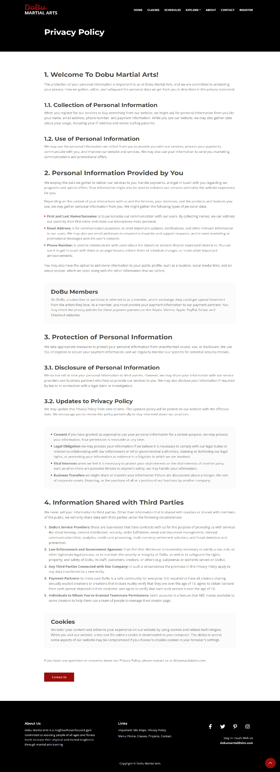

# Testing the Website:

|  |  |  |  |  |  |
| --- | --- | --- | --- | --- | --- |
| Functionality Testing | | | | | |
| No | **Test Case** | **Expected Output** | **Actual Output** | **Test Result** | **Evidence** |
| 1 | Ensure that upon clicking the navigation menu's "Classes" button, the user is redirected to the page displaying available courses. | Upon clicking the "Classes" button located in the navigation menu, redirection will occur to bring users toward the classes page. | Upon selecting the "Classes" tab on the navigation bar, users will be directed to a webpage that contains ample information about various sessions. | Pass | S01, S02 |
| 2 | Make sure the navigation menu on mobile devices correctly collapses and extends | The navigation menu on mobile devices would correctly collapses and extends | The navigation menu on mobile devices correctly collapses and extends | Pass | S03, S04, S05 |
| 3 | Check to see if the class schedules page contains true and current information regarding the class schedules | The class schedules page would contain true and current information regarding the class schedules. | The class schedules page contains true and current information regarding the class schedules | Pass | S06 |
| 4 | Check that the FAQ is well-defined and accessible to users | The FAQ section would be well-defined and accessible to users | The FAQ section is well-defined and accessible to users | Pass | S07, S08, S09 |
| 5 | Does the website display the special courses and services they offer | The website would have a session that display their special courses and services | The website has a session that display their special courses and services | Pass | S10, S11 |

S01



S02



S03



S04



S05

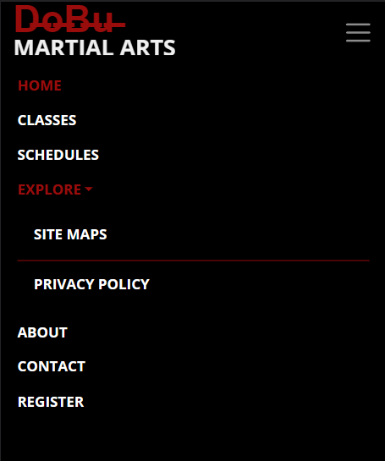

S06

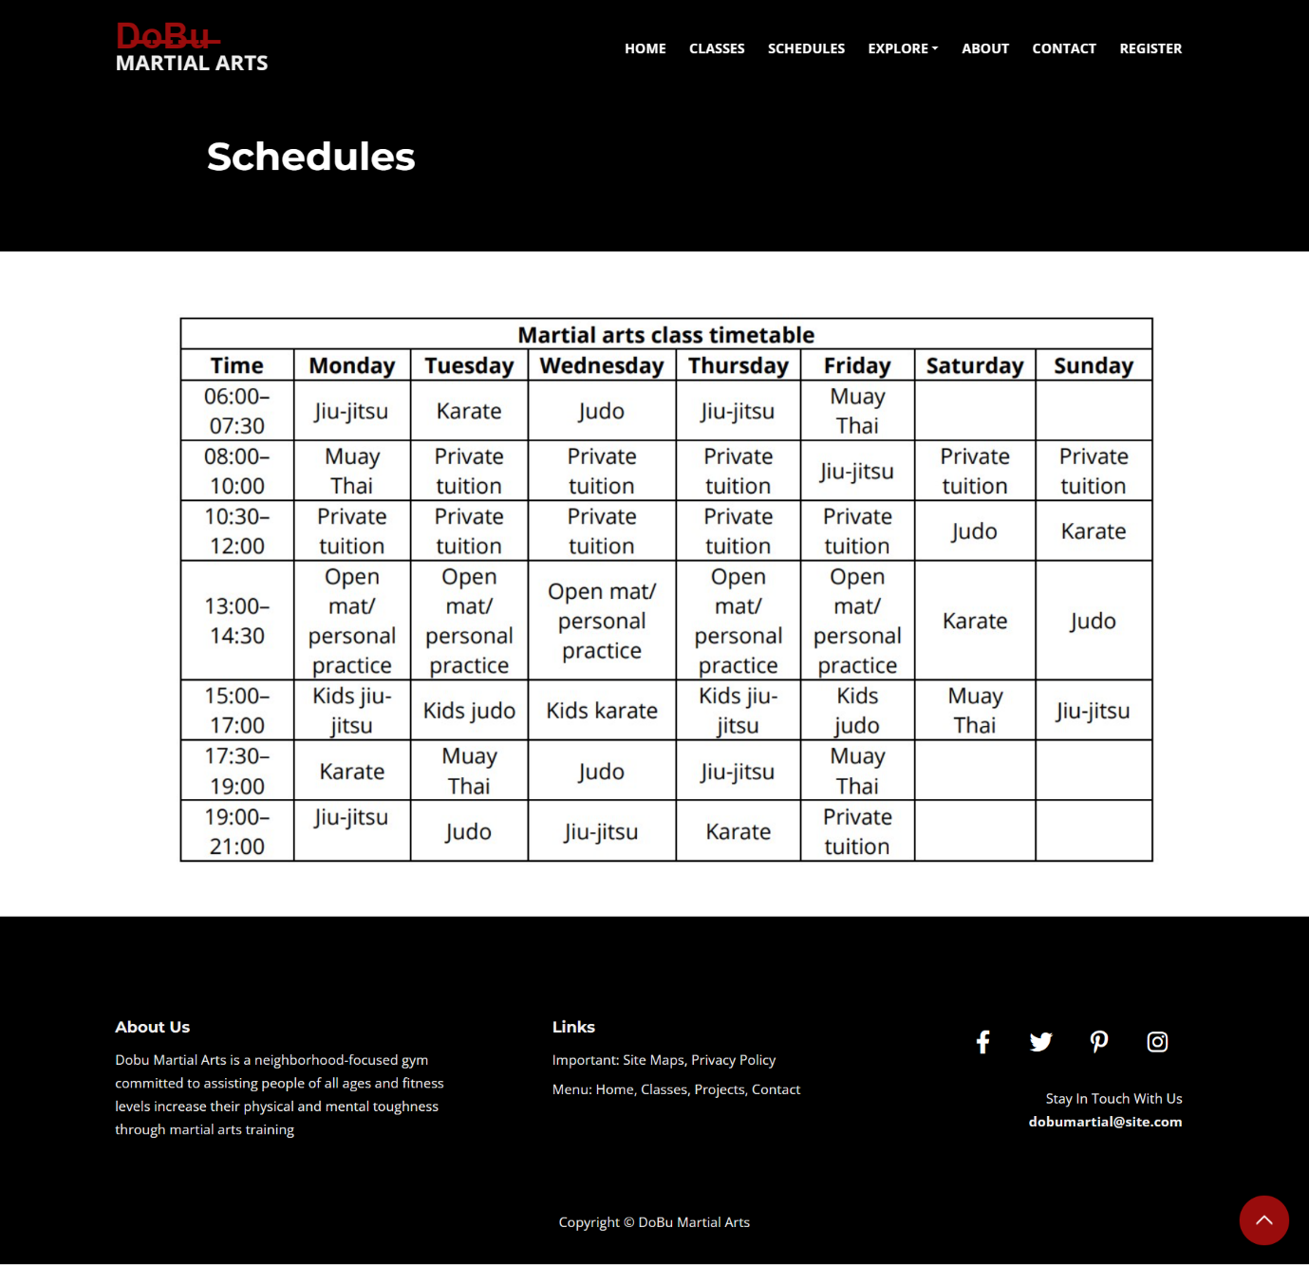

S07



S08



S09



S10

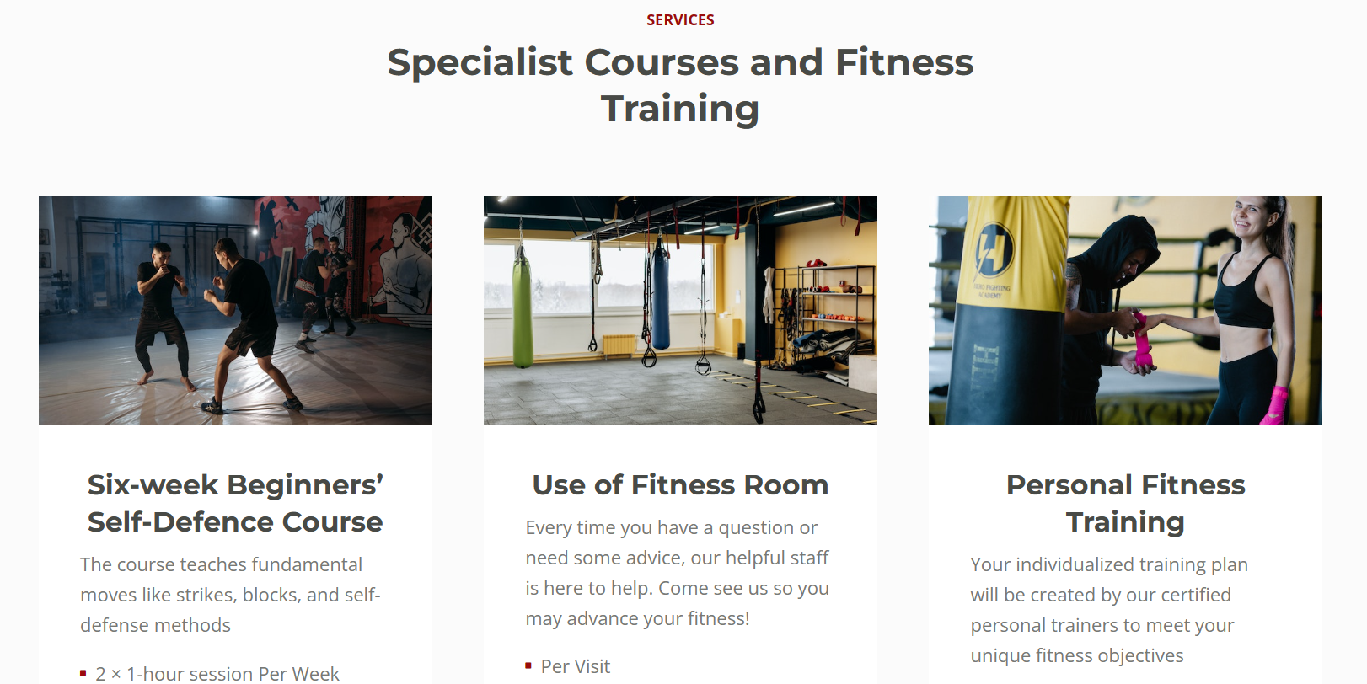

S11

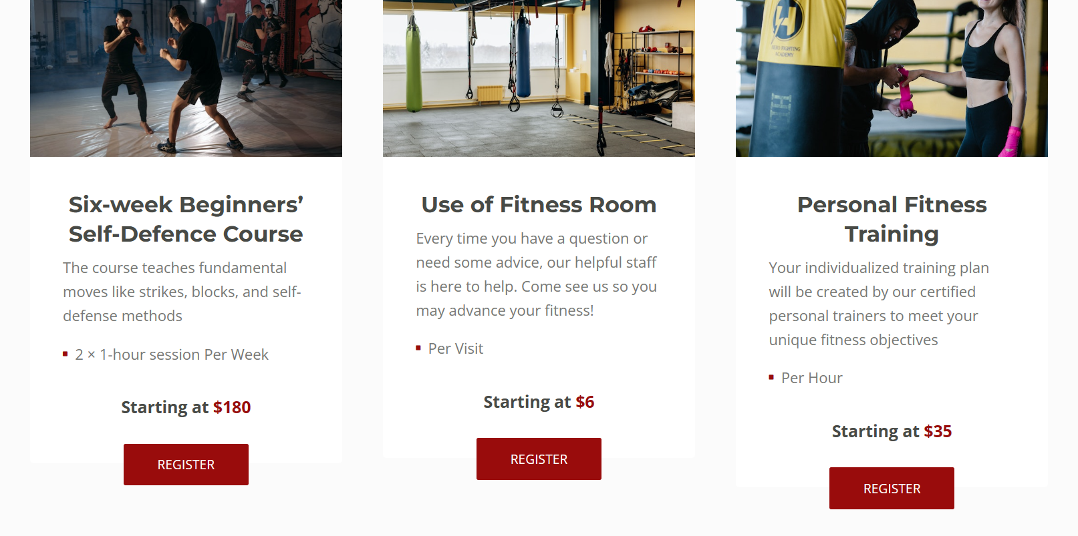

|  |  |  |  |  |  |
| --- | --- | --- | --- | --- | --- |
| Performance Testing | | | | | |
| No | **Test Case** | **Expected Output** | **Actual Output** | **Test Result** | **Evidence** |
| 1 | To make sure it functions properly across all browsers, test the website on various web browsers like Google Chrome, Mozilla Firefox, and Microsoft Edge | The website would work flawlessly in every browser | The website works flawlessly in every browser | Pass | S12, S13, S14 |
| 2 | Test if the links in the footer are working properly | The links in the footer would work fine | The links in the footer are working fine | Pass | S15, S16, S17 |
| 3 | Test if the social icons in the footer are working properly | The social icons in the footer would work perfectly | The social icons in the footer are working perfectly | Pass | S18, S19, S20, S21, S22 |

S12 (Microsoft Edge)

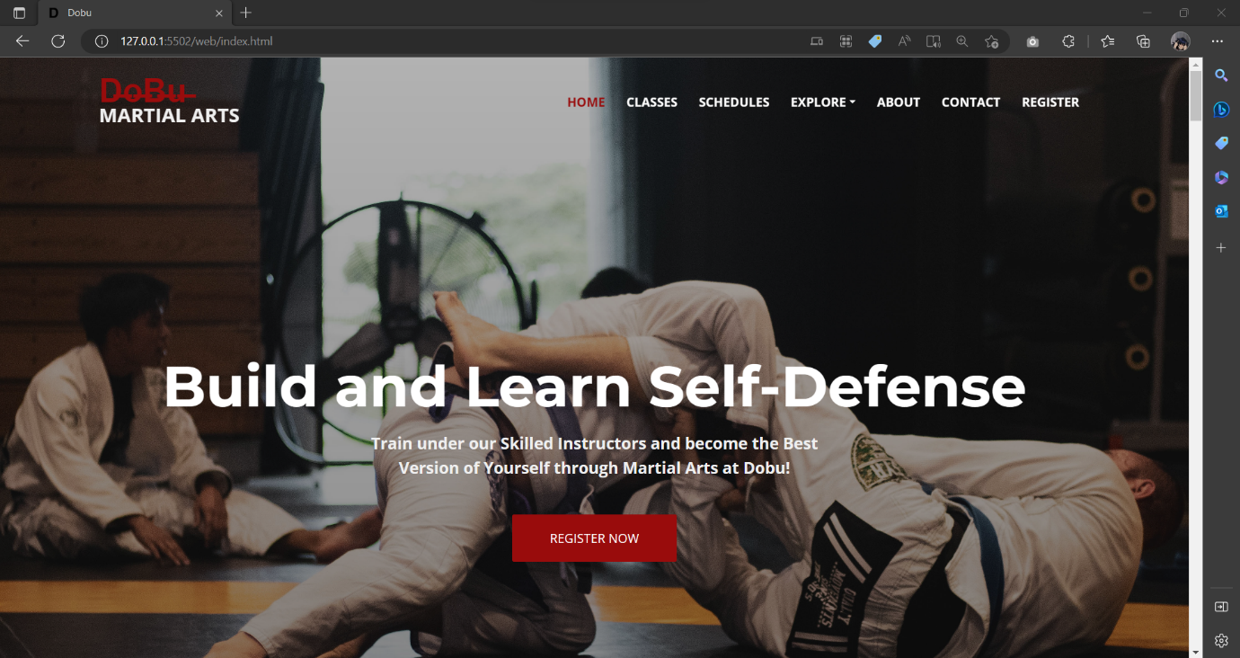

S13 (Google Chrome)



S14(Mozilla Firefox)



S15



S16

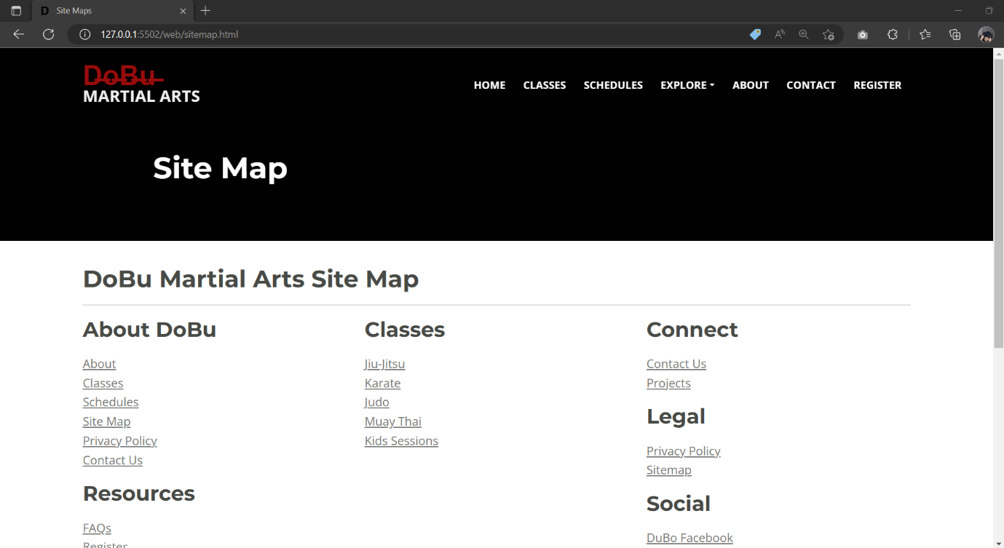

S17

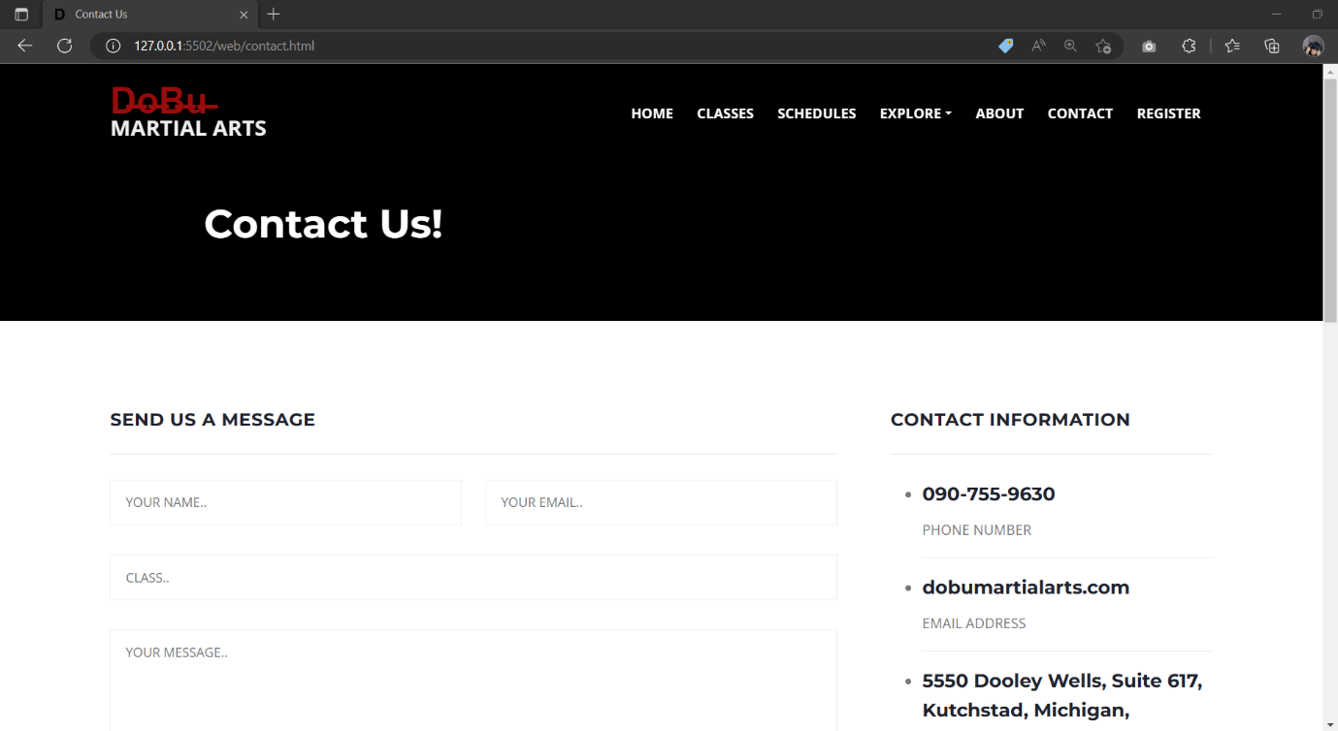

S18



S19



S20

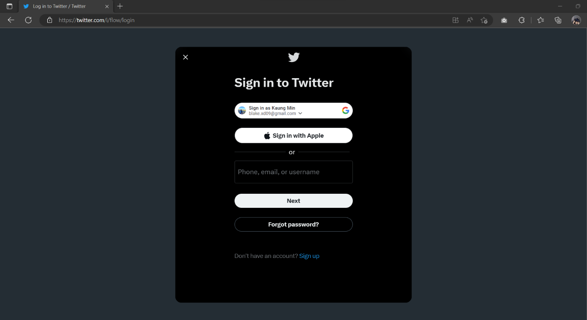

S21

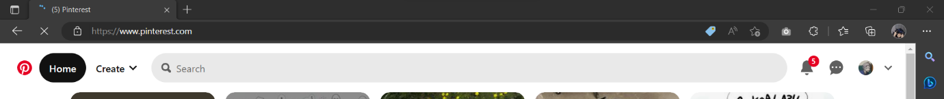

S22



|  |  |  |  |  |  |
| --- | --- | --- | --- | --- | --- |
| Usability Testing | | | | | |
| No | **Test Case** | **Expected Output** | **Actual Output** | **Test Result** | **Evidence** |
| 1 | Is the navigation bar responsive? | For several mobile devices, the nav bar would work great | For several mobile devices, the nav bar works great | Pass | S23, S24 |
| 2 | Is the content on the website simple to read and comprehend? | The contents on the website would be easy to read and understand | The contents on the website are easy to read and understand | Pass | S25 |
| 3 | Is it simple to use and does the website have a contact page where the visitors can connect with the company? | There would be a simple contact page for the visitors to deliver their messages to the company | There is a simple contact page for the visitors to deliver their messages to the company | Pass | S26 |
| 4 | Exactly how useful and accurate are the classes descriptions? | The website would provide the information that the learners need to know about their courses | The website provides the information that the learners need to know about their courses | Pass | S27 |

S23

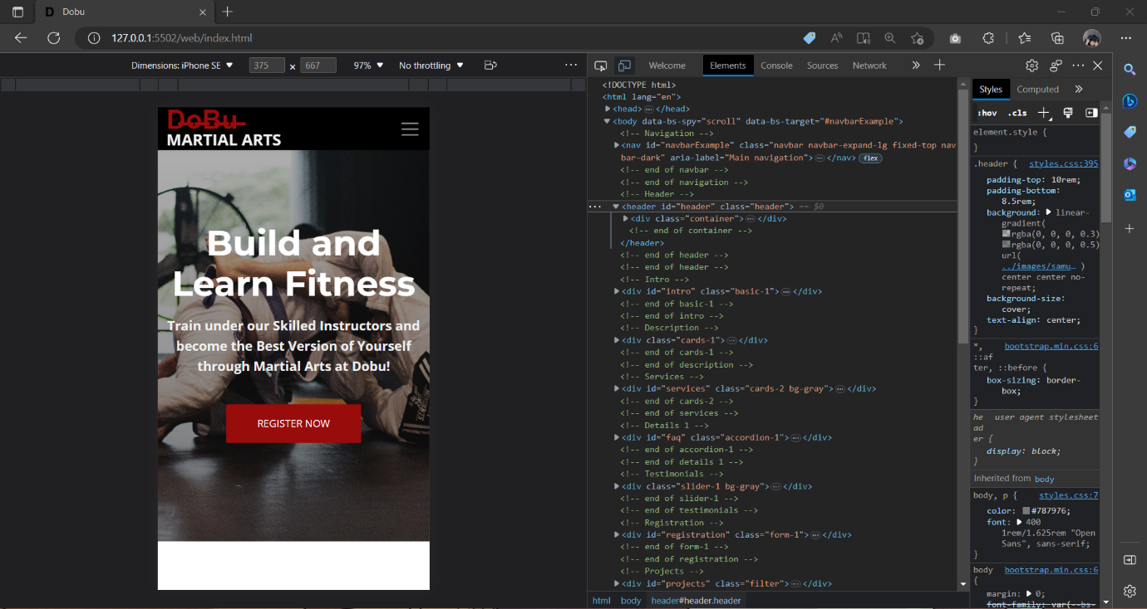

S24

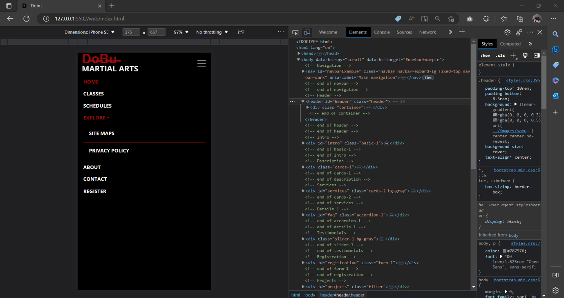

S25

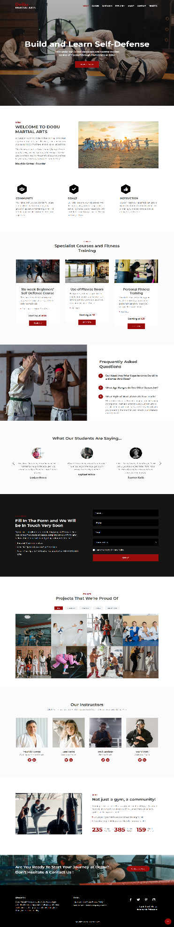

S26



S27

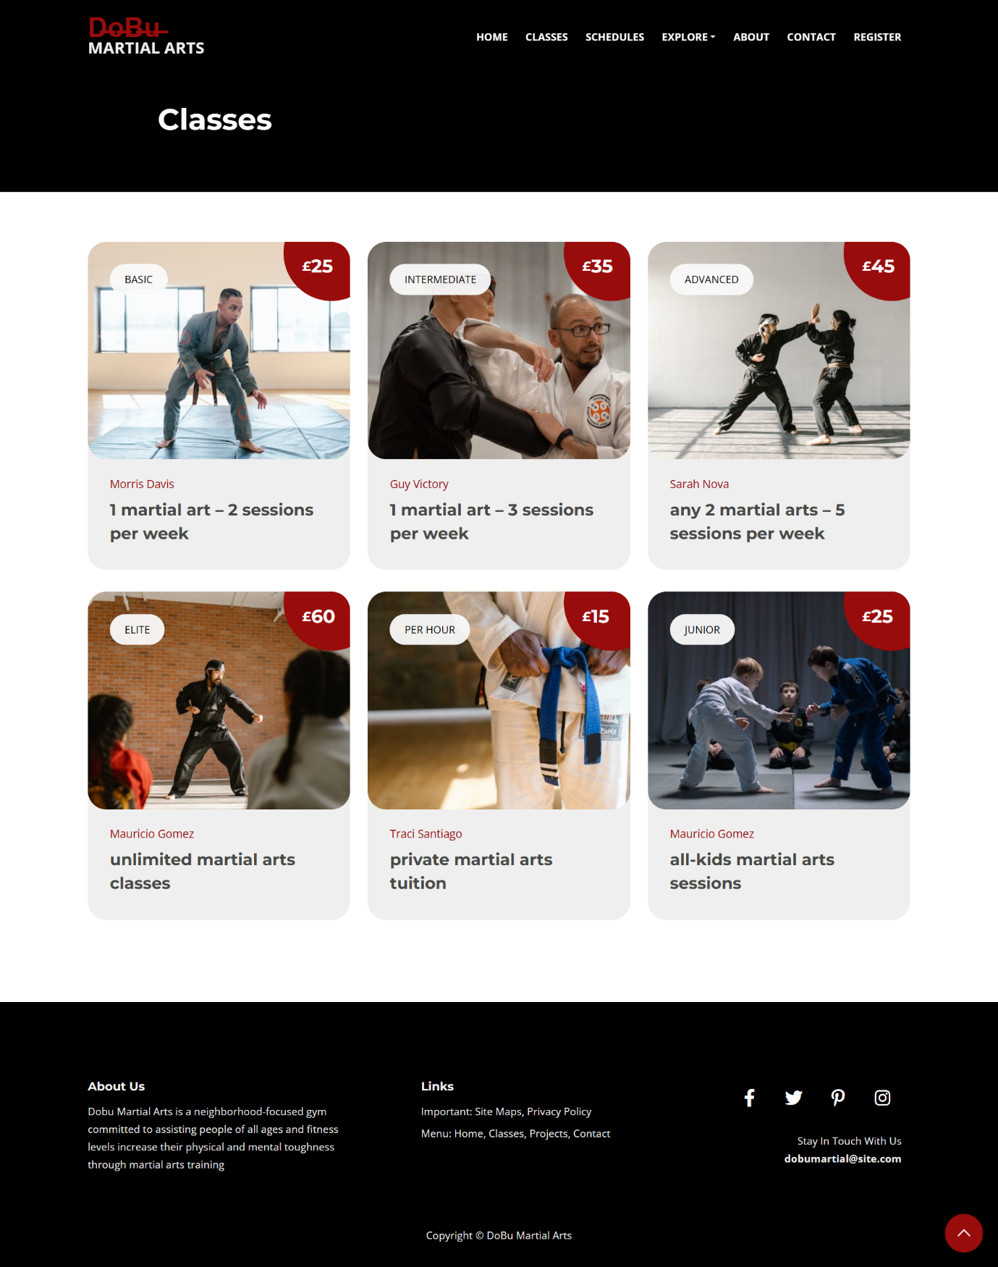

# Web Design Principles:

The DoBu Martial Arts website adheres to the web design guidelines of accessibility, consistency, and simplicity. With a constant structure and color pattern throughout all pages, the website's design is kept straightforward and simple for users to navigate. To ensure that the website is accessible to all users, including those with impairments, accessibility requirements are also followed.

# Standards:

The website's design complies with W3C HTML and CSS standards, ensuring compatibility with many browsers and mobile devices. In order to increase the website's visibility and search engine rating, it also adheres to SEO (Search Engine Optimization) standards, which include the use of pertinent keywords, meta descriptions, and title tags.

# Guidelines:

User-centered design, responsive design, and mobile-first design are all practices that the DoBu Martial Arts website adheres to. To make sure the website satisfies the needs and expectations of the target audience, user-centered design concepts were applied. Furthermore adaptable, the website's design adapts to various screen sizes and resolutions. In order to ensure that the website is optimized for mobile devices, which are becoming more and more popular for internet browsing, a mobile-first strategy was used.

# Appropriate Test Plan

|  |  |  |  |  |  |  |  |
| --- | --- | --- | --- | --- | --- | --- | --- |
| No | Test Scenario | Test Case | Expected Result | Execution Steps | Actual Result | Result | Refer SS |
| 1 | Navigation Testing | To ensure the navigation bar of the website is working properly | Test that all the links are operating properly | Click | As Expected | Pass | S28, S29 |
| 2 | Navigation Testing | To ensure the navigation bar of the website is working properly | Verify the functionality of the menu items and submenu items | Click | As Expected | Pass | S30, S31 |
| 3 | Performance Testing | To ensure the website is functioning fine | Ensure the website's response time satisfies industry standards by testing it | Run the site | As Expected | Pass | S32, S33, S34 |
| 4 | User Registration Testing | To ensure that members can register | Check the registration procedure to make sure all fields are properly validated | Fill the registration form and submit | As Expected | Pass | S35, S36, S37 |
| 5 | Contact Form Testing | To ensure that the contact us page from the website is working properly | Validate that the contact form on the website is functioning as intended | Fill in the contact form | As Expected | Pass | S38, S39 |
| 6 | Content Testing | To ensure that the website is operating finely | To make sure the images, and other media are working properly | Check the website | As Expected | Pass | S40 |
| 7 | Mobile Responsiveness Testing | To ensure that the website is compatible with all kinds of devices and browsers | Check the website's performance on various mobile devices and screen sizes | Inspect the website | As Expected | Pass | S41, S42, S43, S44 |

S28



S29



S30

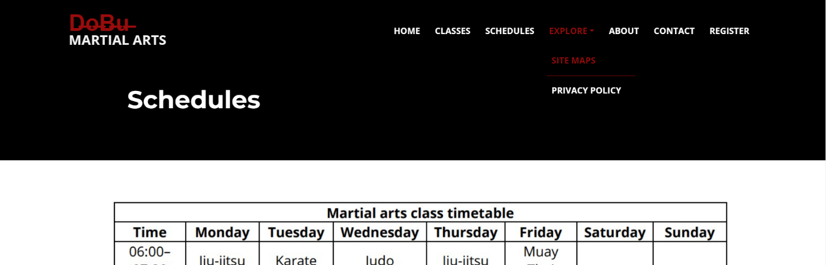

S31

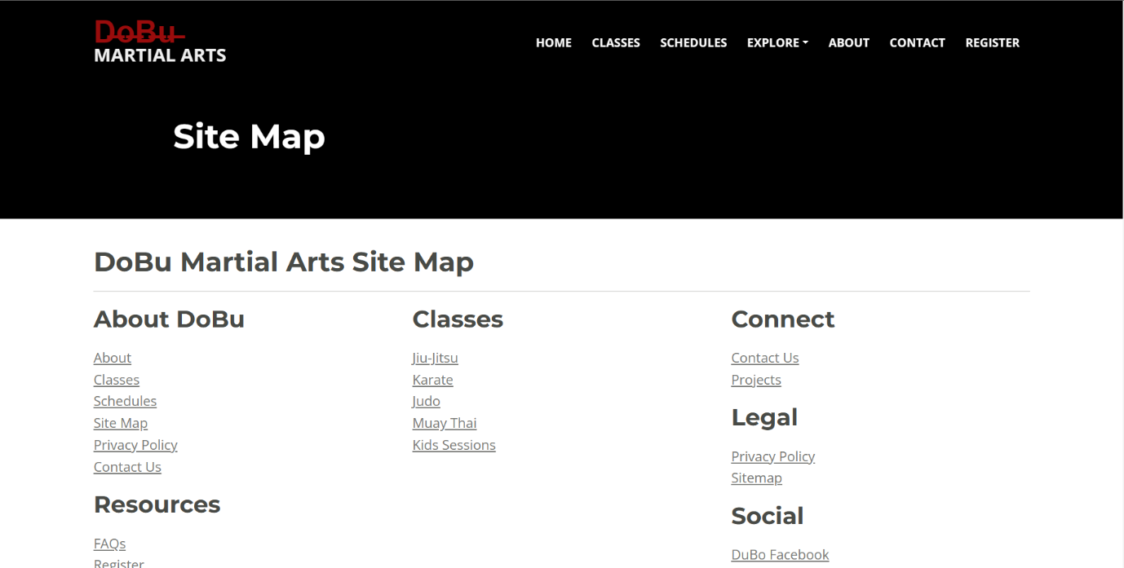

S32

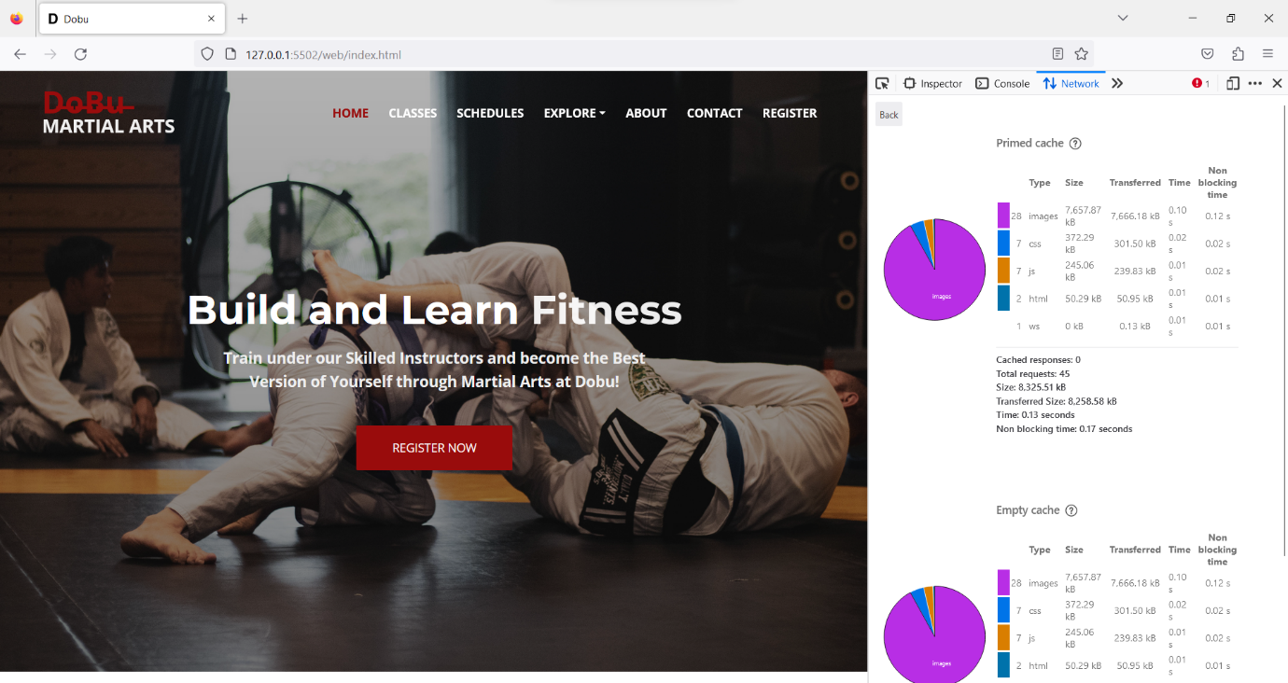

S33

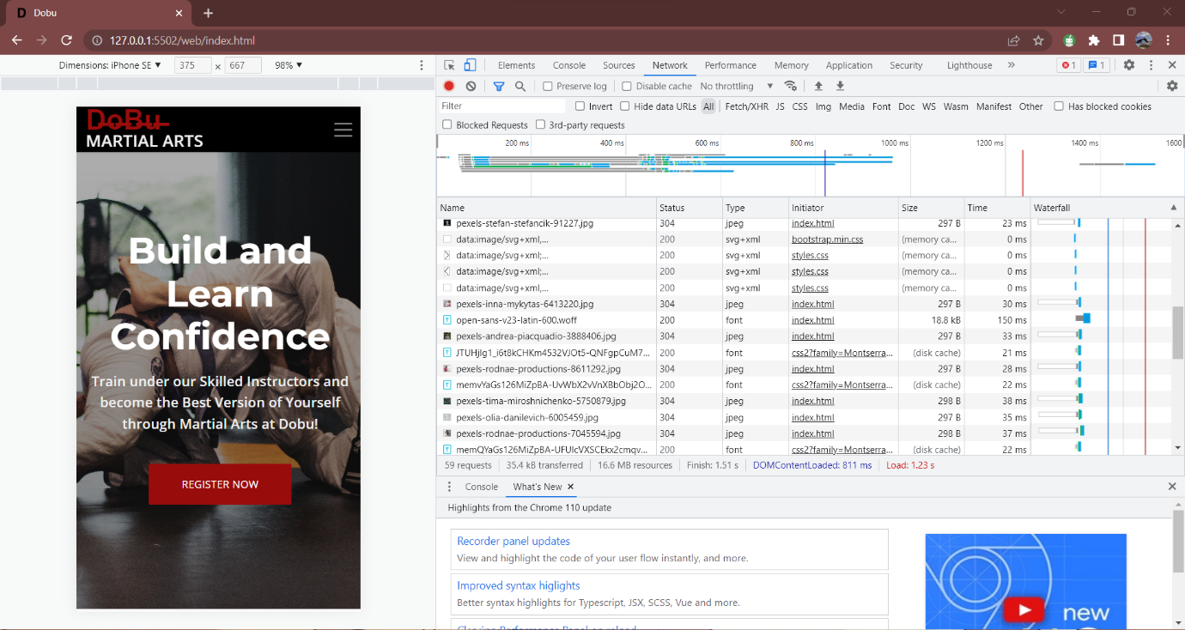

S34

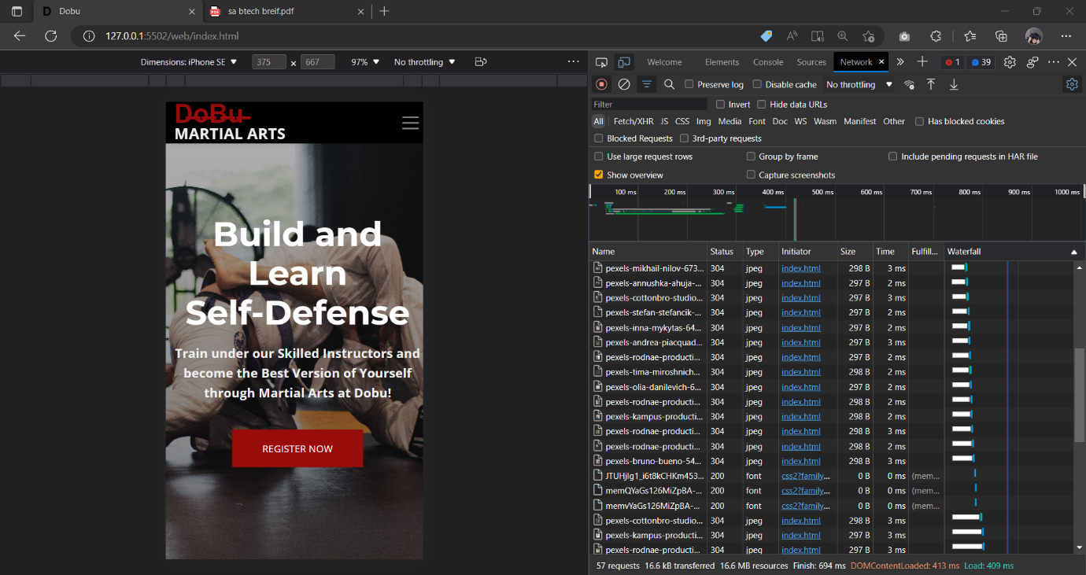

S35

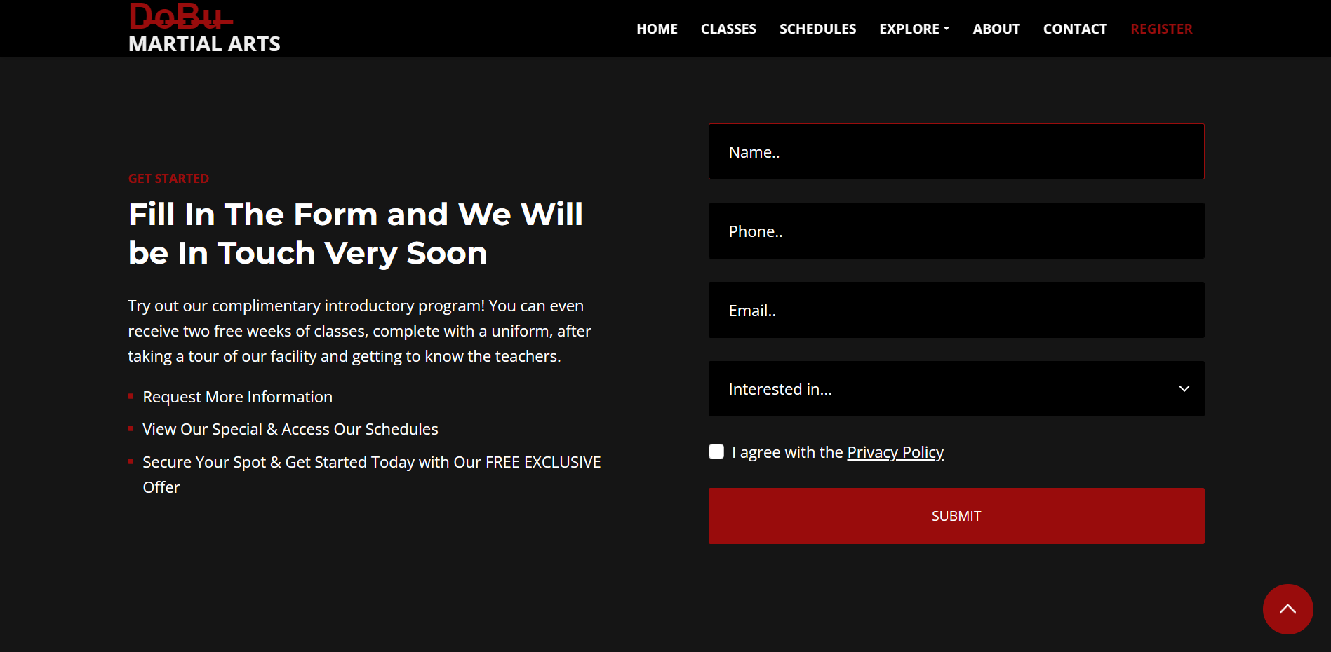

S36

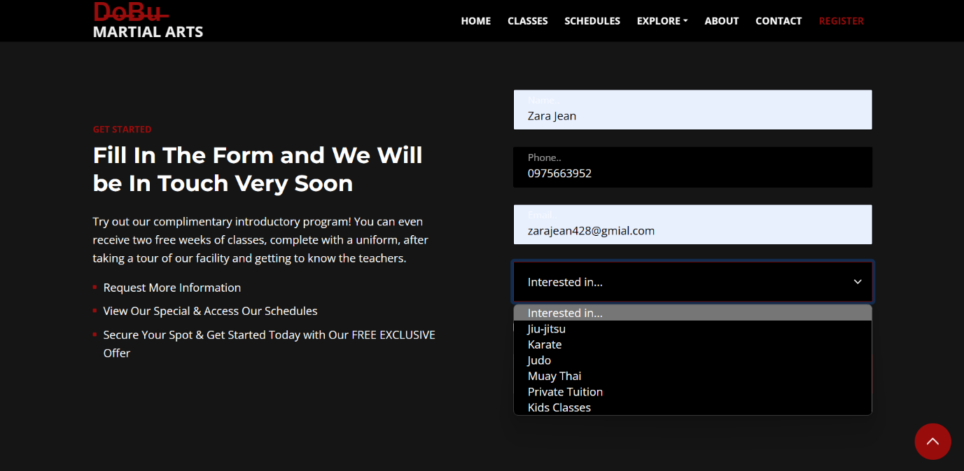

S37

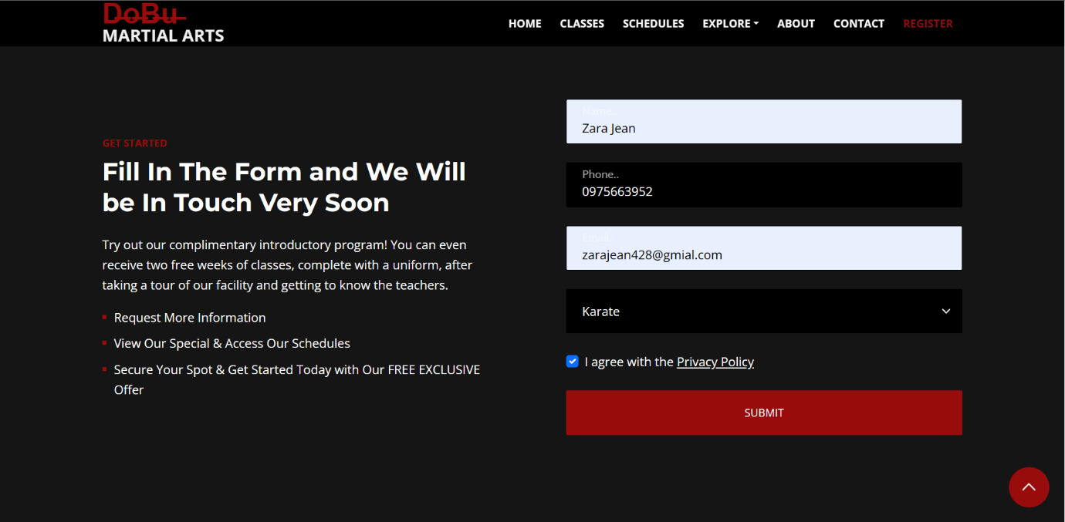

S38

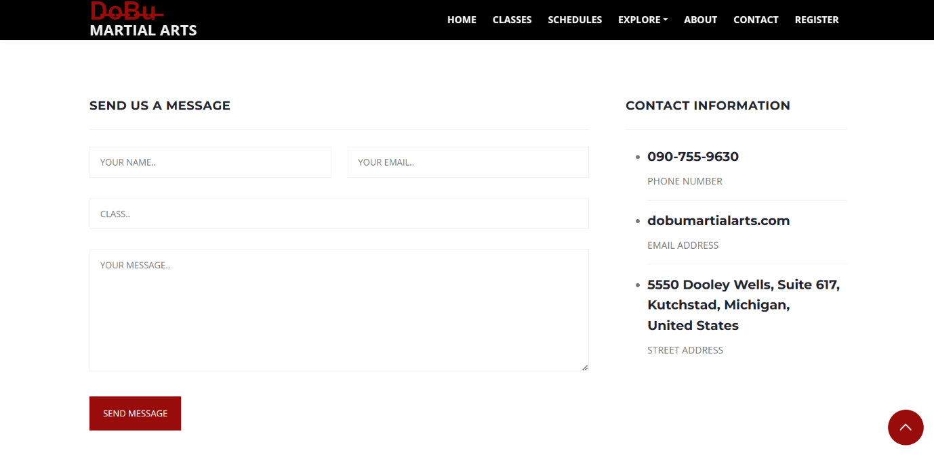

S39

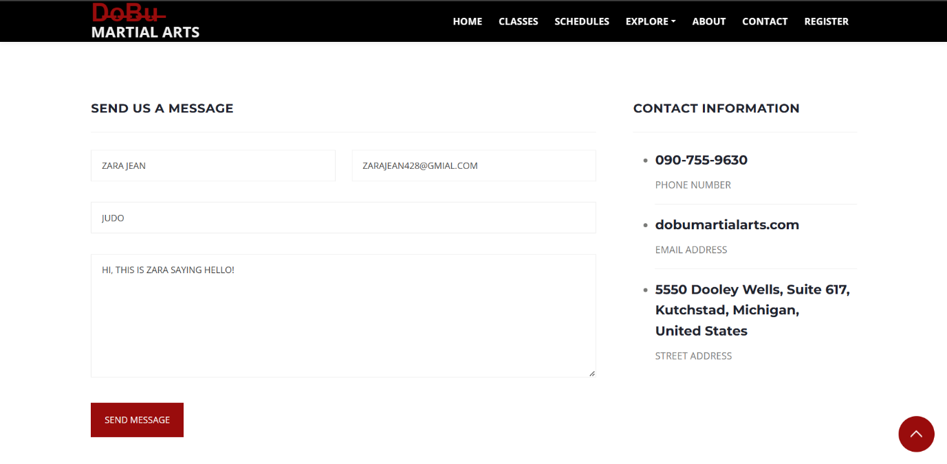

S40

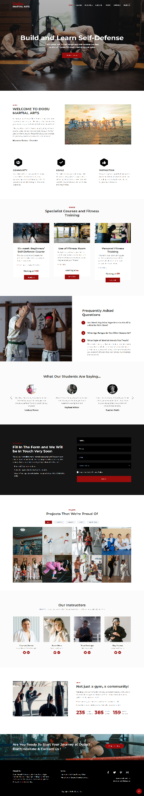

S41



S42



S43



S44

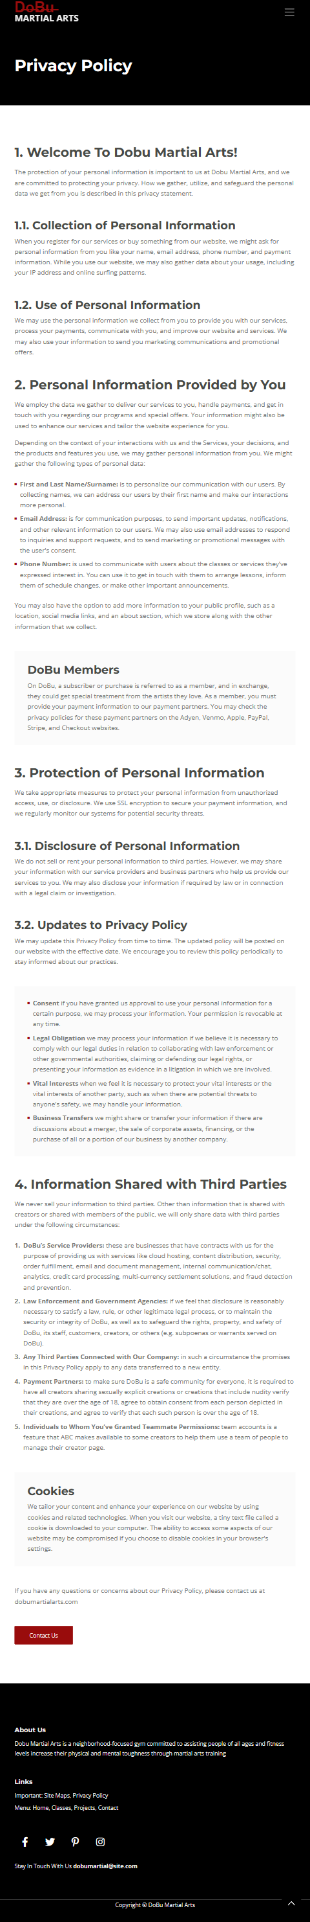

1. [What is DNS? | How DNS works | Cloudflare](https://www.cloudflare.com/learning/dns/what-is-dns/)
2. [What is DNS? | How DNS works | Cloudflare](https://www.cloudflare.com/learning/dns/what-is-dns/)
3. [What is DNS? | How DNS works | Cloudflare](https://www.cloudflare.com/learning/dns/what-is-dns/)